User’s Guide

© 1999-Present Kryptronic, Inc. All rights reserved worldwide. Kryptronic, the Kryptronic logo and all Kryptronic software names and logos are trademarks of Kryptronic, Inc. All Kryptronic software is copyrighted and the intellectual property of Kryptronic, Inc. All Kryptronic software is developed and distributed under license by Kryptronic, Inc. Application Information is available online at http://www.kryptronic.com/.
Table of Contents

Welcome To ClickCartPro/EuropaCart 6
Advanced Features 6
Welcome To The ClickCartPro/EuropaCart User’s Manual 7
System Dashboard 7
The Structure of ClickCartPro/EuropaCart 8
The System Menu 10
Component 10
Profile 10
Settings 11
Cron Settings 11
Joomla! Connector Settings 15
Database 20
Alternate Connections 20
Backup and Restore 21
Raw Database Admin 21
SQL Statement: Submit a Raw SQL Statement 22
Displays 24
Custom Menu 24
Display Includes 25
Display Skins 25
Install New Display Skin 26
Skin Widgets 26
System Messages 27
Extension Modules 27
File Manager 27
Download Files 27
Media Files 28
Upload Download Files 28
Upload Media Files 28
Uploaded Media Files 29
Locations 29
Countries 29
States And Provinces 30
Mail 31
Guest Subscribers 31
Mail Messages 31
Send Mail Message 32
Subscriptions 33
Namespaces 33
Reports 34
Daily Activity 34
Management Activity 35
Monthly Activity 35
Page Access Totals 35
Yearly Activity 35
Software 35
Install Software 35
Installed Software 36
Server News 36
Purchase Software 36
Server News 36
User Accounts 36
Affiliate Payments 36
Generate Affiliate Payments 37
User Accounts 37
The WebSite Menu 39
Component 39
Profile 39
Settings 40
Cron Settings 40
Content 40
Web Pages 40
Dynamic Forms 42
Dynamic Form Fields 42
Dynamic Forms 43
The Store Menu 46
Component 46
Profile 46
Component Name And Description 46
Settings 47
Catalog Global Displays/Settings 47
Cron Settings/Settings 49
General Store Settings 50
Checkout: Allow Guest Checkout 50
Image Specifications 52
Intershipper Settings 52
Language Strings 53
Linkpoint API Settings 53
PayPal Website Payments Pro Settings 53
API Login: User Name 53
Peachtree Export Settings 53
Quickbooks Export Settings 55
Remote E-Commerce Settings 56
Shipping Settings 57
Catalog 58
Categories 59
Category 60
Meta Tags 62
Display 63
Related Categories 66
Visibility 66
Option Selection Items 67
Option Selection Item 67
Price Adjustments 68
Weight Adjustments 69
Digital Download 69
Taxes 69
Product Options 70
Product Option 70
Products 74
Product 74
Pricing 76
Display 78
Related Product Display Information 79
Images 80
Taxes 81
Inventory 82
Delivery 82
Digital Download 85
Relationships 85
Related Product Options 86
Visibility 86
Commerce 87
Checkout Form Fields 87
Selection Items 88
Custom Sale Methods 89
Decrypt Offline Order Data 90
Discount Codes 90
Product Limitations 91
Orders (Completed and Processing) 91
Delete 94
Manage Items 95
Summary/Invoice 95
Post Order Updates 95
Orders (Pending and Cancelled) 96
Delete 99
Manage Items 99
Summary/Invoice 100
Post Order Updates 100
Processing Gateways 100
Supported Payment Methods and Instructions For Installation 103
PayPal Website Payments Pro Management 103
Online Processing Setup 104
Setting Up Specific Online Processors 107
Authorize.Net AIM & Wells Fargo (Authnet Interface) 107
Authorize.Net SIM 108
2CheckOut 108
WorldPay 109
Cardservice Linkpoint (API Only) 109
Cardservice Linkpoint HTML 109
Wells Fargo (BoA Interface) 110
Verisign Payflow Link 111
ECHOnline Credit Card 111
Planet Payment & RTware 112
SkipJack 113
PSiGate 113
NetBilling 113
CyberSource 114
Recurring Billing 116
ProTX/Sagepay Form 117
HSBC Payment Form 117
ePDQ Payment Form 118
Exports 118
Peachtree Accounting Export 118
Customers File 119
Quickbooks Accounting 119
Sage Accounting 119
Modules 119
Shipping 120
Custom Shipping Methods 120
FedEx DirectConnect 121
Configure Intershipper Connection 121
Realtime Carriers 121
Realtime Services 122
UPS Online Tools Connection 123
USPS WebTools 123
Store Displays 124
Category Displays 124
Product Detail Displays 124
Product List Displays 125
Store Menu 125
Kryptronic Software End User License Agreement (EULA) 126
Program Credits 131

Welcome To ClickCartPro/EuropaCart

You have purchased an incredibly powerful tool. You will have infinite power to control virtually every aspect of your customer’s online experience. You should visit this manual after at least completing the Installation Guide and Getting Started Guide. It provides complete details on your ClickCartPro/EuropaCart Web Commerce software.

- Installation: Installing on your server
- Quick Getting Started Guide: Easy to use first steps…create a fully working store quickly and painlessly. We’ll walk you through the setup of your software as well as help you create your first categories, products, etc. We’ll even show you how to make basic adjustments to the look and feel of your site. We’ll also help you get your products loaded in, set up your shipping, billing and other customer interaction and have a fully working backbone that you could put online. Also, through this guide, you’ll start to get an idea how we do things in ClickCartPro/EuropaCart. Eventually, you’ll understand that most of the tables in the product work in a very similar manner.
- ClickCartPro/EuropaCart User’s Guide: This handy reference guide covers every aspect of this software. Each screen and menu item is examined and explained. After you’ve learned the basics, learn the details behind them.

Advanced Features

ClickCartPro/EuropaCart is an advanced Shopping Cart product. It is designed to create a fully working store…whether you’re an 80 Billion dollar nationwide chain or a one-man band. Because of this power, there are certain features in the interface that are designed for a developer with an advanced knowledge of web site programming. We will mark these sections with the following logo:



When you see this logo, you know that you probably shouldn’t fiddle with this tool unless you’re an advanced user. Also, this probably isn’t necessary for 95% of the people who purchase the product. This should save you confusion and time.

Welcome To The ClickCartPro/EuropaCart User’s Manual

If you’ve just completed the Getting Started Guide, most of this will be provided to fill in the blanks. You’re already familiar with navigating the software and setting up your site. But we’ve provided this detailed reference guide so that no question remains unanswered.

System Dashboard

Each time you log into the software, you’ll be greeted by our System Dashboard. Think of this as your Kryptronic Morning News. This is one of the ways that Kryptronic communicates with you on a daily basis. This bulletin board contains important news about the software you own, updates, maintenance fixes and anything else we think you should know. And while it doesn’t contain sports scores, Hollywood news or a political roundtable, it is a good idea to glance at it from time to time to get caught up on this powerful Kryptronic product. You’ll get all of the news you need to know about your site in one handy location, while you drink your first cup of coffee in the morning.

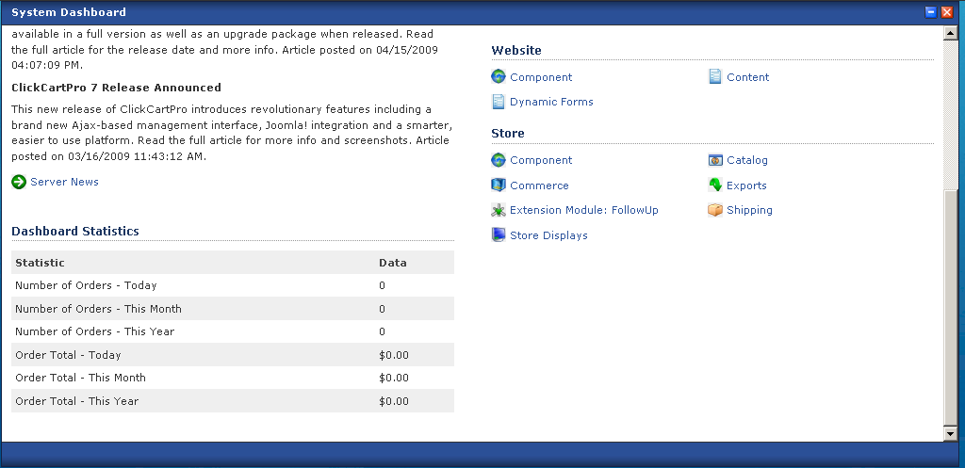

If you ever need to return to the Dashboard once you’ve started working with ClickCartPro/EuropaCart, you simply locate it’s link in the breadcrumbs section located in yellow at the top of your screen.

Dashboard can be launched in an instant…eager to help you.

The Structure of ClickCartPro/EuropaCart

This product is designed much like a database. Clicking on any of theses items will usually present you with table selections and tools for modifying those tables.

For instance, when you click on the Store menu and select the Commerce menu item, you’ll be presented with the following sub menu:

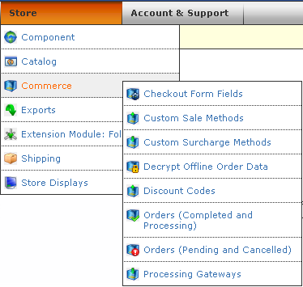

From this selector, you’ll be able to launch the specific table that you wish to modify. In most cases, you’ll have the following menus to choose from:

- Functions Menu- From here, you can either add new items to the table, like products, categories or whatever that particular table controls or you can search the table for a specific item. In the case of a large store with many products, you’ll simply type in a few letters of the product you’re interested in just like a standard search engine.
- Navigation Menu- This will simply tell you how many items are in a particular table and also the number of pages necessary to display those items.
- Data Overview Menu- This is the actual list of items in a particular table. In most cases you’ll have several choices for accessing the data listed.
  - Clone - This makes an exact copy of the item you’re looking at and launches it in the editor. This is ideal when you have several versions of the same product so you can quickly duplicate a majority of the information and then just change certain details.
  - Update- This simply allows you to access the detailed information of a particular table item so that you can modify it.
  - Delete- Just like the sign says…this allows you to delete an item from the table. There is a confirmation window that pops up during Delete, so if you make a mistake, you have a chance to reverse it.
- Database Information- This displays the database SQL coding that tells the database what you’re requesting in this table.

The System Menu
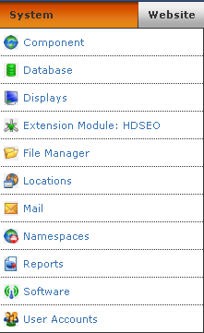

Formerly known as THE CORE, this menu is the gateway to controlling all of the lightning fast background tasks of ClickCartPro/EuropaCart. We’ll explain each individual menu item as well as each item that lies beneath it.

Component
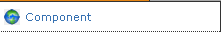

Profile
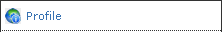

Component Name And Description

Component Name
Enter the name of the component. This name is used in all management interface displays and menus for this application. The default name is System. This is only useful if you want to personalize the Admin section of the product…otherwise, there’s really no reason to change it.

Display Name
Enter the display name of the component. This name is used in all FrontEnd interface displays and menus to reference the component. This is your name for the system. Again, you can change to whatever you choose, but in reality, there’s little reason to change it.

Description
Enter a description for this component. This description is used in management interface menus.

Component Defaults/Component Default Status
Choose whether this component should be the default component for FrontEnd displays. Setting a default here will cause the default status for other components to be unset.

Component Default Namespace
Choose the namespace that should be displayed for this component as the default in the event that a request is received for the component without a namespace referenced.

Default Display Skin
Choose the skin that should be displayed for this component for FrontEnd displays. This skin can be overridden by namespaces and various functions within the software. If you’ve made no changes to the product, you only have a default selection available in the dropdown menu.

Settings

Cron Settings

Last Daily Cron Run
This is the time daily cron tasks were last run for this application.

Last Weekly Cron Run
This is the time weekly cron tasks were last run for this application.

Public Download File Storage Time
Select the number of days to store public download files on the server. You can choose from:
- One Day
- Two Days
- Three Days
- Four Days
- Five Days
- Ten Days
- Fifteen Days
- Twenty Days
- Twenty Five Days
- Thirty Days

Statistics Storage Time
Select the number of days to store statistical information. You can choose from:

- One Day
- Two Days
- Three Days
- Four Days
- Five Days
- Ten Days
- Fifteen Days
- Twenty Days
- Twenty Five Days
- Thirty Days

Unmodified Temp File Storage Time
Select the number of days to store temp files on the server. Temp files are used for a variety of purposes including storing debug information. You can choose from:

- One Day
- Two Days
- Three Days
- Four Days
- Five Days
- Ten Days
- Fifteen Days
- Twenty Days
- Twenty Five Days
- Thirty Days

Unused Session Storage Time
Select the number of months to store session information in the database. Sessions are updated on each access so as long as users have been active within the time period specified, their session information will remain stored. You can choose from:

- One Month
- Two Months
- Three Months
- Six Months
- Nine Months
- Twelve Months

Unused User Account Storage Time
Select the number of years to store unused user accounts in the database. User accounts are updated on each access so as long as users have been active within the time period specified, their user account information will remain stored. You can choose from:

- One Year
- Two Years
- Three Years
- Four Years
- Five Years

Currency Settings: Conversions and Symbols
The core currently supports 7 different currencies and their symbols. You can choose US Dollars, Australian Dollars, Canadian Dollars, Euros, Great Britain Pounds, Japanese Yen, and Swiss Francs. This sections contains the current currency Conversion Rate and Currency Symbol for the various currencies supported.

Important Note:
This process is not updated automatically. If you depend on accurate currency conversions, it is important that you update this section daily to reflect the constantly changing values.

Currency, Weight and Dimensional Settings

Activate Currency Conversion System
Select this to activate the currency conversion system. A true value activates the system and a false value deactivates it. When the currency conversion system is active, customers have the choice to view amounts in their currency. If you activate this system, ensure the conversion rates used by the software are kept up to date. See the Important Note directly above.

Dimensional Unit
Select the dimensional unit used by this software. All dimensions (length, width and height) entered should be made in this dimensional unit. Dimensional conversions are done based on this unit selection to accurately retrieve realtime shipping rate quotes.

System Base Currency
Select the system base currency to be used by this software to perform currency conversions. This system base currency is used as the default entry currency for all currency amounts. You can choose:

- US Dollars
- Great Britain Pounds
- Canadian Dollars
- Euros
- Japanese Yen
- Australian Dollars
- Swiss Francs

Weight Unit
Select the weight unit used by this software. All weights entered should be made in this weight unit. Weight conversions are done based on this unit selection to accurately retrieve realtime shipping rate quotes. You can choose between:

- Pounds (US)
- Kilograms (Non-US)

Date and Time Settings/DateTime Display Format
This is the format which is used to display dates within the software. You can choose between:

- US Format <m/d/Y h:i:s A>
- International Format <d/m/y H:i:s>
- RFC 2822 <Internet Message Format>
- Unix-Style <Seconds Since Epoch>

DateTime Offset In Seconds
If the server clock does not match the actual time you can adjust the time here. This offset is to be entered in seconds.

DateTime Offset Increase/Decrease
If you have a positive 'DateTime Offset In Seconds', choose whether this offset is positive or negative. You can choose:

- Do Not Adjust Server Time
- Add To Server Time
- Subtract From Server Time

Download Directory Settings/Download User Name
This is the username for the public downloads directory.

Download User Password
This is the password for the public downloads directory.

Extension Module Support
This will be another location to check for our Extension Modules(XMODs). See your particular XMOD User Guides for more details.

Frontend Meta Information/Meta Description
Enter a description to be used in the Meta description tag in XHTML displays for pages. This meta tag specification may be overridden on the page level.

Meta Keywords
Enter keywords to be used in the Meta keywords tag in XHTML displays for pages. This meta tag specification may be overridden on the page level.

Meta Title
Enter a page title to be used in the Meta title tag in XHTML displays for pages. This meta tag specification may be overridden on the page level.

Global Settings/Common Site Name
This is the common name to be used for your Internet site. This common name is used throughout the software to display the name of your site.

FrontEnd Interface Default Skin
The default skin for the frontend interface. This skin is used as a default for requests where a skin could not be defined.

Show Delivery Address Book
Select true to display the delivery address book for users. Sites that do not ship any items should not display the delivery address book.

Site Owner Address
Enter the address where the site owner resides below.

Site Owner City
Enter the city where the site owner resides below.

Site Owner Country
Select the country where the site owner resides below. This selection will be used as the default for e-commerce realtime shipping quotes when an item does not have location information present.

Site Owner Fax Number
Enter the fax number for the site owner below.

Site Owner State/Province
Select the state/province where the site owner resides below. This selection will be used as the default for e-commerce realtime shipping quotes when an item does not have location information present.

Site Owner Telephone Number
Enter the telephone number for the site owner below.

Site Owner Zip/Postal Code
Enter the zip/postal code where the site owner resides below. This entry will be used as the default for e-commerce realtime shipping quotes when an item does not have location information present.

Joomla! Connector Settings
Joomla is an award-winning content management system (CMS), which enables you to build Web sites and powerful online applications. Many aspects, including its ease-of-use and extensibility, have made Joomla the most popular Web site software available. Best of all, Joomla is an open source solution that is freely available to everyone. In the past, folks have been underwhelmed by the choices available for compatible shopping carts…no longer…CCP can make your Joomla site a major e-commerce player.

Activate Joomla! Single-Sign-On
This status indicator allows you to activate (true) or deactivate (false) Joomla! Single-Sign-On. If you activate Joomla! Single-Sign-On, user information between this software and Joomla! will be synchronized and users will be given access to all resources when logging into either system.

Activate Joomla! Skin Importer
This status indicator allows you to activate (true) or deactivate (false) the Joomla! Skin Importer. If you activate the Joomla! Skin Importer, this software will import the template from Joomla! and use that template as a skin for all displays.

Activate Joomla! Skin Widget Export
This status indicator allows you to activate (true) or deactivate (false) Joomla! Skin Widget Exports. If you activate Joomla! Skin Widget Exports, skin widgets will be available to modules for inclusion in the Joomla! template.

Joomla! Connector Password
Enter the password used for the ClickCartPro/EuropaCart Connector component. This password is used to prevent unauthorized access to system resources. This password should be entered in the ClickCartPro/EuropaCart Connector component in your Joomla! installation exactly as it's entered here.

Joomla! Location (URL)
Enter the full URL to the Joomla! installation you wish to connect to. This installation of Joomla! must have the ClickCartPro/EuropaCart Connector component, the ClickCartPro/EuropaCart system, user and authorization plugins, and the ClickCartPro/EuropaCart display modules installed, configured and activated. Example: 'http://www.yourdomain.com/joomla/index.php'.

Language Strings
This area contains language strings that could be changed in the event you plan on localizing this software for different languages. This is only one of several locations that would need to be changed.

Mail Settings/ Guest Subscription Opt Out Link Text
This text is used to pre-populate guest subscription messages. The purpose of this text is to provide an opt-out notice for email subscribers as may be required by law.

Site Owner Email Address
This email address is used as a default address for the site owner.

User Account Subscription Opt Out Link Text
This text is used to pre-populate user account subscription messages. The purpose of this text is to provide an opt-out notice for email subscribers as may be required by law.

Management Interface Settings/ Default DB Results Per Page
This is the default number of database results to display per page for management interface data displays. Users can select to view more or less results per page when using database search functions. You can choose from:

- 50 Results Per Page
- 100 Results Per Page
- 150 Results Per Page
- 200 Results Per Page
- 250 Results Per Page

Default Skin: BackEnd Interface
The default skin for the management interface.

Last News Download
This is the time news was last downloaded from the central server for this application.

Search Engine Optimization Settings/Google Analytics Account
Enter your Google Analytics account number to automatically track all URLs generated by this software through Google Analytics. Leave this field blank to disable Google Analytics usage.

SEO Status
Enable Search Engine Optimization (SEO) here. If you choose to enable SEO you will need to set up URL rewrite rules within your server configuration or server account. Information can be found in the manual on how to do this. Turning this feature on will produce search engine friendly URLs for FrontEnd application pages. A full tutorial of this setup is included in your Getting Started Guide.

Suppress SID in URLs
SIDs are used in URLs by default to track users when the system cannot determine whether a cookie has been set. Select true to suppress SIDs from URLs and false to include them. If you choose to suppress SIDs, cookies will be required to maintain login status.

Security Settings/Banned IP Addresses
If you would like to ban IP addresses from accessing resources and applications controlled by this software, enter a single or comma delimited list of IP addresses below. You can ban a single IP address or all IP addresses in a domain. To ban a single IP address, enter the full address (Example: 192.168.1.1 would ban the address 192.168.1.1). To ban all IP addresses in a domain, enter a partial address (Example: 192.168. would ban all IP addresses matching 192.168.x.x).

Upload File Size Maximum
Enter the maximum file size, in bytes, that may be uploaded when a file is uploaded by a user. Please note that the actual limit on the size may be further restricted by web server settings.

Upload File Types Allowed
This checklist allows you to define the types of files you will allow to be uploaded by users.

Session and Cookie Settings/Days Until Cookie Expiration
Enter the number of days that must elapse before a cookies are deleted from a user's computer due to inactivity.

Days Until Cookie Refresh
Enter the number of days that must elapse before a cookie is refreshed on a user's computer to prevent deletion due to expiration.

Minutes of Inactivity Before User Logout (FrontEnd)
Enter the number of minutes that must elapse before a user is logged out automatically due to inactivity. This applies to frontend interfaces.

Minutes of Inactivity Before User Logout (Management Interface)
Enter the number of minutes that must elapse before a user is logged out automatically due to inactivity. This applies to the management interface.

Statistical Settings/Enable Statistical Logging
Statistical logging can be turned on or off here. Logging should be enabled unless your server is under heavy load and you want to conserve resources.

Tax Settings
This form is used to update the various tax settings in CCP.

Country Tax: Active Rules
Here, you can select the active country tax rules to use for calculating country taxes. When using Standard Country Tax Rules, country taxes are calculated for all countries selected in Standard Country Tax Rules Taxable Countries. When using European Union VAT Country Tax Rules, EU VAT rules apply to all EU countries.

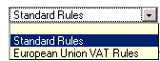

Country Tax: European Union VAT Rules - Catalog Price Tax Entry
For European Union VAT Tax Rules, select whether catalog prices are entered including or excluding tax.
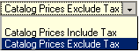

Country Tax: European Union VAT Rules - Company Affiliations
For European Union VAT Country Tax Rules, enter any affiliations your company may have with trade or professional associations. Include membership details and registration numbers for each.

Country Tax: European Union VAT Rules - Company Tax Registration Number
For European Union VAT Country Tax Rules, enter the tax registration number for your company. If you enter a tax registration number in this field, it will be displayed on the Company Information page.

Country Tax: European Union VAT Rules - Display Tax
For European Union VAT Tax Rules, select whether to display catalog prices including tax, excluding tax or both.

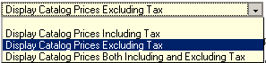

Country Tax: European Union VAT Rules - Display Tax Summary In Orders
For European Union VAT Country Tax Rules, select True to display a tax summary for orders. Select False to suppress this display.

Country Tax: European Union VAT Rules - Display Zero Tax
For European Union VAT Tax Rules, select true to display zero tax information for catalog prices where zero tax is calculated

Country Tax: European Union VAT Rules - Home Country
For European Union VAT Country Tax Rules, select the home country for calculating tax.

Country Tax: European Union VAT Rules - Home Region
For European Union VAT Country Tax Rules, select the home region for calculating tax.

Country Tax: European Union VAT Rules - Tax Excluded Text
For European Union VAT Tax Rules, enter the text to be used to denote a price excluding tax. Default: Exc VAT

Country Tax: European Union VAT Rules - Tax Included Text
For European Union VAT Tax Rules, enter the text to be used to denote a price including tax. Default: Inc VAT

Country Tax: European Union VAT Rules - Tax Name
For European Union VAT Country Tax Rules, enter the name to be used for the tax. Default: EU VAT.

Country Tax: European Union VAT Rules - Tax Zero Text
For European Union VAT Tax Rules, enter the text to be used to denote a price with zero tax. Default: Zero VAT

Country Tax: European Union VAT Rules - Validate Tax Exemption Numbers
For European Union VAT Country Tax Rules, select true to validate European Union VAT tax exemption numbers when entered by users. Select false to skip validation and accept all entries.

Country Tax: Standard Rules - Tax Name
For Standard Country Tax Rules, enter the name to be used for the tax. Default: Country Tax.

Country Tax: Standard Rules - Taxable Locations
Here, you can select all of the countries in which a country tax should be charged.
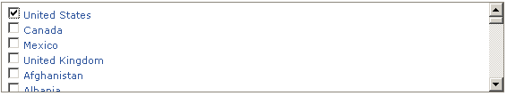

State and Province Tax: Taxable Locations
Here you can select all of the states and provinces where state and province taxes should be charged.
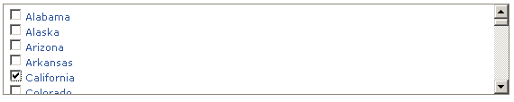

Wholesale and Affiliate Account Settings/Affiliate System Status
Select below to activate the affiliate system. A true value activates the system and a false value deactivates the system. If active, customers with basic accounts will have the option to request an account upgrade to make their account an affiliate account. If you activate the affiliate system, be sure to add commissions to e-commerce application products and product options.

Maximum Order Commission
The maximum per-order commission setting for affiliates sets the maximum commission amount that will be paid to an affiliate for orders they generate. Enter '0.00' to use no maximum.

Track Affiliates Across Sessions
Select below to track affiliates across sessions. If set to true, when a customer clicks an affiliate's link, that customer is assigned to that affiliate for the lifetime of their session and all future orders under that session will be attributed to the originating affiliate. If set to false, returning customer orders will not be assigned to the affiliate unless the affiliate's link is used to access the store again.

Wholesale System Status
Select below to activate the wholesale system. A true value activates the system and a false value deactivates the system. If active, customers with basic accounts will have the option to request an account upgrade to make their account a wholesale account. If you activate the wholesale system, be sure to add wholesale prices to e-commerce application products and product options.

Database

Alternate Connections

Database/Alternate Connections
Use this interface to manage alternate database connections. Alternate database connections are used within this software to provide access to database accounts other than the primary account configured during installation. Alternate connections allow for data management and are required by some import and upgrade modules. If you would like to change the settings for the primary database connection used by this software, access the installer script you used to install the software on this webserver account. There are no alternate connections provided on a new install.

Backup and Restore
Use the interface below to backup and restore the database tables associated with the Primary Connection. Clicking here allows you to quickly make a backup of your entire database structure. It is probably a good idea to visit this area from time to time and backup your system. Like all backups, they only become important when your world comes crashing down. This is a multi-step process which moves rather quickly and looks like the screen below:

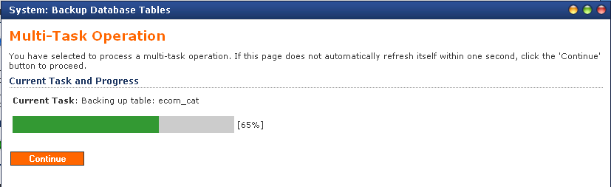

Once you’ve made a backup, you’ll notice a new file appears that you can access to restore your entire table system in the event of an emergency.

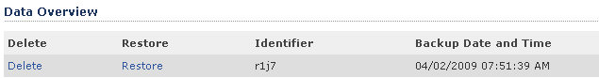

Raw Database Admin

This is your archive of active databases that are being used by your Frontend product like ClickCartPro/EuropaCart. Here you can upload, download, browse, maintain and control your products, categories, discounts, gateways and the other databases which control the data of the Frontend product. This area is reviewed in great detail in our Getting Started Guide. If you haven’t gone through it, you haven’t been following directions…give yourself 2 demerits and a firm slap on the wrist.

SQL Statement: Submit a Raw SQL Statement
Here, you will enter an SQL statement to execute against any database table or tables. This is a raw statement that is unguided and unmanaged. All types of statements are allowed. When issuing statements that return result sets, use a LIMIT clause to control the size of the result set. It is possible here to return all rows from a database table or tables, so be careful with the amount of data you choose to return.

SQL Statement
Enter an SQL statement to submit against the database. Read the note above about limiting result sets for statements that select data.

Output Type (Select Statements)
Select the output type for SELECT statements or statements that produce results. You’ll have the choice of:

- XHTML Table
- XML Data Structure (Normal)
- XML Data Structure (System)
- CSV (Comma Separated Value) Text

Change Active Connection: Use a different database connection.
Available Database Connections
Select the connection you would like to use while working in Raw Database Admin.

This dropdown box only contains the Primary Connection.

Create A New Table: Create a new table within this database.
Table Information/Table Name
Enter the name of the table you would like to create. The table name should be entered in lowercase letters using characters a-z and the underscore character (_) only.

Table Display Name
Enter a display name for this table.

Table Description
Enter a description for this table.

Primary Key Column/Column Name
Enter the name of primary key column for this table. The primary key column name should be entered in lowercase letters using characters a-z and the underscore character (_) only.

Display Name
Enter a display name for this column.

Column Type
Select the column type for the primary key column. Most relational database management systems do not support CLOB type columns as a primary key column. Using a VARCHAR type is recommended if this column will hold text. You can choose from:

- Text (VARCHAR)
- Character Large Object (CLOB)
- Floating Point Integer (FLOAT)
- Integer (INT)

Column Numeric
Enter the numeric length for the primary key column. This numeric is not needed for CLOB type columns. Most relational database management systems set the maximum length for columns as follows: VARCHAR: 255, INT: 4, FLOAT: 8.

Column Section Name
The column section name is used for backend interface displays to separate columns in XHTML forms. Enter a section name for this column.

Column Description
Enter a description for this column.

Database Overview
This is your master database control center. You can Browse, Maintain, Import, Export and Manipulate the tables that control your site here. Again, this is covered in much more detail in the Getting Started Guide.

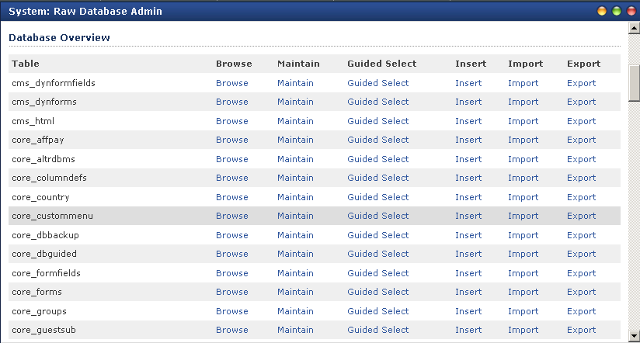

Displays

Custom Menu

Application
The application with which this menu is associated.

Namespace
Select the namespace used to handle requests for this menu item. Example: Select 'Web Page - display' to target user-created web pages.

Display Name
Display name for this menu item used in the menu.

Reference String
Enter a reference string to be passed to the namespace associated with this menu item. Example: Enter 'splash' to target the splash page for the 'Web Page - display' namespace.

Display Order
The menu display order numeric allows display of menu items in the custom menu in a particular order. The menu items are sorted in ascending order based on this numeric indicator.

Status
This indicator controls whether this menu item is displayed in the custom menu. Select true to display the menu or false not to display it.

Display Includes

Display Name
Include display name as displayed in management interfaces.

Application
The application with which this include is associated.

Include Content
This content should be written in standards compliant XHTML and should contain PHP code.

Description
Description of the include.

Display Skins
Display Skins
Currently installed skins are presented here. To update a skin, click the Update link. To delete a skin, click the Delete link. If you would like to create a new skin based on an existing skin, use the Clone option.

Install New Skin:
Use this form to install a new skin. Skins installed via this form should be stored in a properly formatted skin TAR archive file. If you choose to install a skin that already exists, the installed skin id will be appended with a numeric character in order to provide the newly installed skin with a unique id.

If you’ve purchased your skin from Kryptronic, there is a full tutorial of Skin installation in your Getting Started Guide.

Skin Installation File
Browse your local hard drive and select the skin installation file for the skin you wish to install. This file will be used to install a new skin.

Installed Skins
Update A Skin
Presented in this section are the files controlled by a particular skin. Options are available to view and/or update these files as well as delete the skin-controlled files. The main skin layout file is located in the Base Directory and is named 'skin.php'.

File Contents
Update the contents of the file below. Please read the note above on updating PHP files and how to correct errors.

Install New Display Skin

If you’ve purchased your skin from Kryptronic, there is a full tutorial of Skin installation in your Getting Started Guide.

Skin Installation File
Browse your local hard drive and select the skin installation file for the skin you wish to install. This file will be used to install a new skin.

Installed Skins
Update A Skin
Presented in this section are the files controlled by a particular skin. Options are available to view and/or update these files as well as delete the skin-controlled files. The main skin layout file is located in the Base Directory and is named 'skin.php'.

File Contents
Update the contents of the file below. Please read the note above on updating PHP files and how to correct errors.

Skin Widgets

Update
Skin Widget/Application
The application with which this widget is associated.

Namespace
The namespace with which this widget is associated.

Name
The name used to identify this widget.

Status
This indicator controls whether this widget is active. Select true to display the widget or false not to display it.

Display/Display Order
The display order numeric allows display of widgets in a particular order. The widgets are sorted in ascending order based on this numeric indicator.

Display Group
The display group indicator is used in conjunction with the display skin to control where this widget is presented. The default skin uses two groups, LEFT and RIGHT to indicate whether a widget is displayed in the left column or the right column in the skin.

System Messages

Application
The application with which this message is associated.

Message Identifier
The message string is used to identify this message within the software.

Message Type
The message type. You can choose from:

- Normal
- Confirmation
- Error

Message Text
The actual text displayed for this message.

Extension Modules

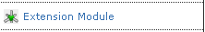

Extension Modules (XMODs)
Several of our new XMOD plug-ins work directly from the core. If you have any of these extra features installed on your site, this is where you would access them.

One example would be our Hi-Def SEO module.

File Manager

Download Files

Presented here are public and private download files that are available to save and delete. To save a file, right click on the Save link and choose to save the file to your local hard drive. To delete a file, click the Delete link.

During the installation of this software, the public download directory should have been password protected for security purposes. If this installation step was done, the username and password used for that directory are listed below.

Username: Username
Password: uM”‡3†

Download Files: Public Directory
This is your list of public files available for download.

Download Files: Private Directory
This will be a list of those files that can only be downloaded with a password.

Media Files

Media Directory
Select the media directory to manage.

Upload Download Files

Download File
Browse your local hard drive and select the download file you wish to upload.

Download Directory (Public or Private)
Select the directory to which you would like this file uploaded. If you select to upload to the public downloads directory, the file you upload will be available for immediate download. If you select to upload to the private directory, the file will be available for software functions to copy to the public directory at a later time. You’ll have your choice of:

- Public Directory
- Private Directory

Upload Media Files

Media File
Browse your local hard drive and select the media file you wish to upload.

Media Directory Selection
Select the media directory to which you would like to upload a file. Again, you’ll have a choice of:

- Public Directory
- Private Directory

Uploaded Media Files

Presented in this space are public and private uploaded files that are available to save and delete. To save a file, right click on the Save link and choose to save the file to your local hard drive. To delete a file, click the Delete link.

Locations

Countries

Full Country Name
The country's full name.

Country ISO Code
The country's two letter ISO code or abbreviation.

HSBC Country Code
This is the numeric country code used by HSBC.

Sort Order
This sort order numeric allows display of countries in a particular order. Countries are sorted in displays in ascending order based on this numeric indicator.

Tax Information

Shipping Tax Rate (Percentage)
Enter 0.000 for no shipping tax.

Item Reduced Low Tax Rate (Percentage)
Enter 0.000 for no tax on items.

Item Reduced Mid Low Tax Rate (Percentage)
Enter 0.000 for no tax on items.

Item Reduced Mid High Tax Rate (Percentage)*
Enter 0.000 for no tax on items.

Item Reduced High Tax Rate (Percentage)*
Enter 0.000 for no tax on items.

Item Standard Tax Rate (Percentage)*
Enter 0.000 for no tax on items.

Display/Display in Contact Forms
Indicates whether this country will be available in the contact information section of forms.

Display in Delivery Forms
Indicates whether this country will be available in the delivery information section of forms.

States And Provinces

Full State Province Name
Primary key. The state/province name should be entered here.

State/Province ISO Code
The state/province's two-letter ISO code or abbreviation.

Country
Country in which this state/province is located. Blank entries are allowed.

Sort Order
This sort order numeric allows display of states/provinces in a particular order. States/Provinces are sorted in displays in ascending order based on this numeric indicator.

European Union Status
Indicates whether this state/province is located in the European Union. If this state/province is located in the EU and European Union VAT Country Tax Rules are active, this state/province will be taxable under European Union VAT Country Tax Rules.

Tax Information/Item Tax Rate (Percentage)
State/Province tax rate. Enter 0.000 for no tax.

Shipping Tax Rate (Percentage)
State/Province shipping tax rate. Enter 0.000 for no tax on shipping.

Display/Display in Contact Forms
Indicates whether this state/province will be available in the contact information section of forms.

Display In Delivery Forms
Indicates whether this state/province will be available in the delivery information section of forms.

Mail

Guest Subscribers
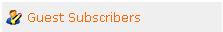

This will be a listing of those guests who have signed into your site.

Mail Messages

Application
The application with which this mail message is associated.

Display Name
The display name for this mail message.

Text Message
Enter the text content for this message below. This message content can contain PHP code. If you choose to use PHP code in the message content, base your PHP code on the includes used by this software.

Default Subject
If a subject is not specified by the calling application, this subject is used as a default rather than producing an error.

XHTML Message/Send XHTML Message (In Addition To Text)
Indicator used to control whether an XHTML message will be sent in addition to a text message for this mail message.

XHTML Message Skin
The skin used to use for the mail message XHTML display. This skin selection overrides the default Mail skin (Mail) used for all messages by default.

XHTML Message Include
Enter the XHTML content for this page below. If you choose to use PHP code in the page content, base your PHP code on the includes used by this software.

Sender and Recipients/Default Message Sender (From)
If a sender is not specified by the calling application, this sender is used as a default rather than producing an error.

Default Message Recipient (To)
If a recipient is not specified by the calling application, this recipient is used as a default rather than producing an error.

Additional Message Recipients (TO)
Enter a comma-delimited list of recipients to be added to the TO message header.

Additional Message Recipients (CC)
Enter a comma-delimited list of recipients to be added to the CC message header.

Additional Message Recipients (BCC)
Enter a comma-delimited list of recipients to be added to the BCC message header.

Message Subject Options/Subject Prepend String
This string is prepended to the mail message subject if specified. (Added to the beginning of the subject).

Subject Append String
This string is appended to the mail message subject if specified. (Added to the end of the subject).

Send Mail Message

Send Mail Message/From Email Address
Enter the email address which should be used as the from email address for the mail message.

Message Subject
Enter the message subject for the mail message.

Text Message
Enter the plain text message below. This text should be plain ASCII text.

Recipients/To Email Addresses
Enter the email addresses for the mail (To) recipients of the mail message. You can enter a single address or a comma-delimited list of addresses.

Cc Email Addresses
Enter the email addresses for the carbon copied (Cc) recipients of the mail message. You can enter a single address or a comma-delimited list of addresses.

Bcc Email Addresses
Enter the email addresses for the blind carbon copied (Bcc) recipients of the mail message. You can enter a single address or a comma-delimited list of addresses.

XHTML Message Information/Send XHTML Message (In Addition To Text)
Indicates whether an XHTML message will be sent in addition to a text message for this mail message.

XHTML Message Skin
The skin used to use for the mail message XHTML display.

XHTML Message
Enter the text for the XHTML message below. This text should be properly formatted XHTML. You must complete this field in order to send an XHTML message. If this field is not completed, only a plain text message will be sent.

Subscriptions

Update/Display Name
Enter a display name for this subscription. Changing the name of this subscription does not affect user subscription status.

Namespaces
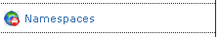

Use this interface to manage System Namespaces. System Namespaces are pointers to different functions within the software that control the operation of the software. Every request made executes a namespace - whether the namespace is included in the request URL, or the default namespace for a particular application is executed. Namespaces allow for different modules and functions to take control of various tasks performed by the software. Namespaces use permissions to control security for those tasks.

Update/Application

The application with which this namespace is associated.

Namespace Region
This is the namespace region to which this namespace belongs. Multiple namespaces can belong to the same region, however only one namespace can be active per region.

Display Name
The display name for this namespace. This display name is used for page titles and statistical logging.

Active Status Indicator
The active status for this namespace. If you select to make this namespace active, all other namespaces that belong to the same namespace region will become inactive.

HREF Link Type
Select the type of link to use for this namespace. A selection of SSL here will force all links printed by the software to point to https URLs. A selection of Non-SSL here will force all links printed by the software to point to http URLs.

Permissions/Allowed Groups
This is a comma-delimited list of user groups that are allowed access to this namespace. If all groups are allowed access to this namespace by default, enter an asterisk here. Edit this field in conjunction with the Denied Groups field. If you choose to allow access to this namespace for all user groups (enter an asterisk here), the Denied Groups field must be completed with a comma-delimited list of denied user groups (allow all but those denied) or must be left empty (everyone is allowed access to this namespace).

Denied Groups
This is a comma-delimited list of user groups that are denied access to this namespace. If all groups are denied access to this namespace by default, enter an asterisk here. Edit this field in conjunction with the Allowed Groups field. If you choose to allow deny to this namespace for all user groups (enter an asterisk here), the Allowed Groups field must be completed with a comma-delimited list of allowed user groups (deny all but those allowed) or must be left empty (everyone is denied access to this namespace).

Display/Default Skin
Choose the skin that should be displayed for this namespace. If no entry is made here the application default will be used. This skin can be overridden by other namespaces and various functions within the software.

Reports

The Core automatically generates a series of reports which you may find useful for both marketing and administration.

Daily Activity

Daily activity simply provides a basic report of numbers of entries to the Frontend of the site.

Management Activity

This is a report that spells out management activity on your site and the IP address of those individuals who accessed the Management Interface of the site.

Monthly Activity

Again, this is a simple report that tells you the activity on the front end of the site for the month.

Page Access Totals

Simple report that provides page names in hit count.

Yearly Activity
Activity on the front end of the site broken down by year.

Software

This area tracks your software installations, mods, etc. and keeps you posted on updates and options available to you from Kryptronic. It is a good idea to check this area regularly as well as you Admin news page to make sure you’re running the latest and greatest version of your Kryptronic product.

Install Software
This software is updated using the installer script you used to initially install the software. If you have purchased software upgrades or new software and would like to install that software, access the installer script.

Each time updates are released, you will be notified via email as well as post a news article that will be downloaded and viewable in the Server News function within this management interface. It is recommended that you check for software updates regularly using the installer script.

Software updates are released regularly to maintain the security, stability and functionality of the system.

Installed Software
This installed software display provides information on all Kryptronic software. Information for all software modules is listed on this page.

Server News
This is an access point to the Server News. It is important to check this regularly to make sure you are keeping your Kryptronic products up to date.

Purchase Software
This software is an advanced web application framework which allows you to install multiple applications and modules for those applications in order to customize your Internet site and management experience.

Different applications and application modules, as well as upgrades for those applications and modules, are available for purchase. If you would like to purchase new software applications and/or modules for your installed applications, you can follow the link below to review what is available and make purchases.

Each time upgrades and new software is released, you will be notified via email as well as post a news article that will be downloaded and viewable in the Server News function within this management interface.

Server News
This is an access point to the Server News. It is important to check this regularly to make sure you are keeping your Kryptronic products up to date.

User Accounts
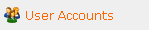

Affiliate Payments
This will be a listing of your current affiliate payments.

Generate Affiliate Payments

The Generate Affiliate Payments function is used to generate commissions for any affiliate account holders who are currently owed commissions. All amounts in this area are shown, stored and must be entered in the system base currency (USD).

User Accounts

This area houses all of the various accounts that you or your customers have set up. Here, you’ll have access to all of the information on those accounts.

Update
User Account/Email Address
Unique User ID.

Username
You can insert a unique user name in this field.

Password
User password. This password is stored as an MD5 hash.

User Group
Group the user belongs to. You can choose from:

- Admin-Backend Admin
- Affiliate-Affiliate Account
- Reports- Backend Reports
- Superuser-Backend Superuser
- Users-Basic Account
- Wholesale- Wholesale Account

Last Access Time
When was the last time that this user accessed the site?

Contact Information
This is basic name, address, etc.

Billing Address
These are just standard billing address fields for your customers. It is similar to your standard contact info address information except that it also includes and additional field:

Residential/Commercial Status
Address listed at residential <R> or commercial <C> status

Subscriptions
What active subscriptions does this account holder have?

- General email subscription list
- Internet site news and updates
- Product news and updates

Affiliate Information/Affiliate ID
This field is used for affiliate accounts only. Enter a unique affiliate ID here that will be used in affiliate links to associate orders with an affiliate. Be sure this ID has not been used by another affiliate to avoid crossing commissions and data.

Affiliate Commission Percentage
This field is used for affiliate accounts only. This field holds the commission percentage for an affiliate account. If you set this field to '0.000', static price amounts entered on the product and product option level in ecommerce applications will be used to calculate commissions. If you set this percentage to a number greater than zero, the affiliate will earn commission based on the entered percentage.

Affiliate Sales (Total)
This field is used for affiliate accounts only. This field holds the total amount of sales generated by this affiliate to date. Initially this field should be set to '0.00'. This amount is stored in the system base currency.

Affiliate Commission Earned (Total)
This field is used for affiliate accounts only. This field holds the total amount of commission earned by this affiliate to date. Initially this field should be set to '0.00'. This amount is stored in the system base currency.

Affiliate Commission Owed (Current)
This field is used for affiliate accounts only. This field holds the total amount of commission owed to this affiliate currently. Initially this field should be set to '0.00'. This amount is stored in the system base currency.

Affiliate Commission Paid (Total)
This field is used for affiliate accounts only. This field holds the total amount of commission paid to this affiliate to date. Initially this field should be set to '0.00'. This amount is stored in the system base currency.

Wholesale Information/Wholesale Account Discount Percentage
This field is used for wholesale accounts only. This field holds the discount percentage for a wholesale account. If you set this field to '0.000', static price amounts entered on the product and product option level in ecommerce applications will be used to calculate the wholesale price for items. If you set this percentage to a number greater than zero, the wholesaler will receive a discount based on the entered percentage.

Currency/Preferred Currency
This field is used when the currency system is active. Users can select the currency in which they wish to view prices. This selection is updated via the Currency form in the FrontEnd interface main skin menu.

The WebSite Menu

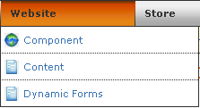

The Website Menu is where you’ll manage the content of your web site. This isn’t the commerce area, but rather the area where you manage the web pages that provide content the supports your commerce. You’ll deal with your products, categories, etc. in the Store Menu…this is where you create the “meat” of your web site. This section of the manual will explain each and every line item of the Website Menu. It is set up as if you clicked on the first item on the left and then clicked on each menu item in the order they are displayed.

Component
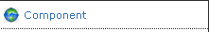

Use this option to manage defaults and settings. This refers to the application itself and how it names the categories and functions it uses internally.

Profile
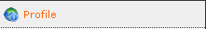

Component Name And Description/ Component Name
Enter the name of the component. This name is used in all management interface displays and menus for this component. The default name is Website. This is only useful if you want to personalize the Admin section of the product…otherwise, there’s really no reason to change it.

Display Name
Enter the display name of the component. This name is used in all FrontEnd interface displays and menus to reference the component. This is your name for the Website within your site. If you refer to your site as the Wizbang Hammer Store, then this is what you would type in here to refer to.

Description
Enter a description for this component. This description is used in management interface menus.

Component Defaults/Component Default Status
Choose whether this component should be the default component for FrontEnd displays. Setting a default here will cause the default status for other components to be unset.

Component Default Namespace
Choose the namespace that should be displayed for this application as the default in the event that a request is received for the application without a namespace referenced. You can choose:

- Web Page
- Dynamic Form
- Dynamic Form- Process

Display Skin Override
Choose the skin that should be displayed for this component for FrontEnd displays. This skin can be overridden by namespaces and various functions within the software.

Settings

Cron Settings

Last Daily Cron Run
This is the time daily cron tasks were last run for this application.

Last Weekly Cron Run
This is the time weekly cron tasks were last run for this application.

Content
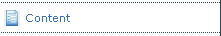
This is where you will store and edit any content pages on your site. These will be the pages that support your product, category and other sales-based pages. This Web page repository now also allows you to quickly audition any page by clicking on the Audition Page Link located to the left of the identifier name.

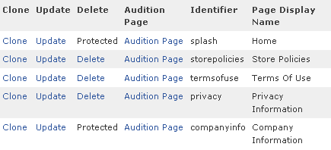

Web Pages

Update/Web Page/Identifier
Enter a unique identifier for this page. This identifier will be used in URLs to link to this page.

Page Display Name
This is the page display name. It is used in menus and recent actions to identify the page.

HTML Content
Enter the content for this page below. This content should be written in standards compliant XHTML and can contain PHP code. If you choose to use PHP code in the page content, base your PHP code on the includes used by this software.

WYSIWYG editing has been disabled for this field because it contains PHP code.

Date/Time Stamp
This displays the last time this page was updated.

Display/Menu Order
The menu order numeric allows display of pages in menus in a particular order. Menu options are sorted in ascending order based on this numeric indicator.

Menu Display
Select below whether to include this page in software generated menus for frontend displays. Select true to display, false to suppress.

Page Title Display
Select below whether to show a page title in the XHTML display for this page.

Display Skin
Choose the skin that should be displayed for this page. If you do not select a skin to display, the application or namespace default skin will be used.

Meta Tags/Meta Title
Enter a page title to be used in the Meta title tag in XHTML displays for this page.

Meta Keywords
Enter keywords for this page to be used in the Meta keywords tag in XHTML displays for this page. The default for this application will be used if no keywords are entered.

Meta Description
Enter a description of this page to be used in the Meta description tag in XHTML displays for this page. The default for this application will be used if a description is not entered.

Visibility/Page Visibility Selection
This field allows you to control which users can view this page. You can set this page up to be viewed by anyone, only users belonging to the groups you specify using the Page Visibility Groups field, or to be hidden from everyone.

Page Visibility Groups
If you selected to allow only certain user groups to access this page under the Page Visibility Selection field, select the groups for which this page should be made visible.

You can select from several choices…
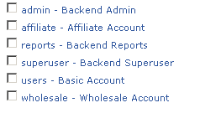

Dynamic Forms

Dynamic Form Fields

Form Field/Identifier
This is the unique id for this dynamic form field.

Controlling Dynamic Form
The form that controls the form field.

Display Name
The display name for the field used in XHTML output and in mail messages.

Form Section
The name of the section of the form this field should be printed in. To create a new section, simply enter in a section that has not yet been used.

Display Description
The description to be displayed for the form field in XHTML output.

The WYSIWYG Editor

Important Note:

All Kryptronic products now contain a WYSIWYG (What You See Is What You Get) editor on fields that contain XHTML code. Why is this, you may ask? Now, text entries can be automatically converted to XHTML by simply typing them into this field and then clicking on the Bold/Italic/Underline and other text tools just like you do in a word processor. The software now just converts it for you so you don’t have to learn basic HTML programming. To launch the WYSIWYG editor just click on the blue WYSIWYG Editor: Load Editor link located in the various appropriate fields. It will launch the WYSIWYG toolbar that looks like this:

Field Order
The field order numeric allows display of the fields in the form in a particular order. The fields are sorted in ascending order based on this numeric indicator.

Field Settings/Default Value
Enter the default value to be used to pre-populate this field.

Email Field Indicator
Set this field to true if this field is an email address field and it should be used to populate the from email address in the dynamic form mail message.

Required Indicator
Indicator used to determine whether an entry for the form field is required.

Form Field Type
This is the XHTML form field type used to display the dynamic form field. If you select a field type of Selection, Checkboxes or Radio Buttons, be sure to enter at least one Selection Item below. You can choose from:

- Textbox
- TextArea Regular
- TextArea Small
- Selection List (List)
- Checkboxes (List)
- Radio Buttons (List)
- Hidden Field
- Captcha (Image Verification) Field

Selection Items (List Fields)

Dynamic Forms

Form/Identifier
This is the unique id for this dynamic form. It is used as a reference string in URLs to identify this form.

Display Name
The display name of this dynamic form.

Form Description Header
The description containing form instructions used during XHTML output.

Important Note:

All Kryptronic products now contain a WYSIWYG (What You See Is What You Get) editor on fields that contain XHTML code. Why is this, you may ask? Now, text entries can be automatically converted to XHTML by simply typing them into this field and then clicking on the Bold/Italic/Underline and other text tools just like you do in a word processor. The software now just converts it for you so you don’t have to learn basic HTML programming. To launch the WYSIWYG editor just click on the blue WYSIWYG Editor: Load Editor link located in the various appropriate fields. It will launch the WYSIWYG toolbar that looks like this:

Mail Message/Default From Email Address
Enter the email address which should be used as the from email address for the mail message in the event that no form fields are marked as the from email address field.

Message Subject
Enter the subject for mail messages sent for this dynamic form.

Message Header Text
Enter text to be presented at the top of the mail message sent for this dynamic form. Do not include XHTML tags in this text. XHTML tags will be added automatically if an XHTML message is to be sent.

Send XHTML Message (In Addition to Text)
Indicator used to control whether an XHTML message will be sent in addition to a text message for this mail message.

XHTML Message Skin
The skin used to use for the mail message XHTML display. This skin selection overrides the default Mail skin (Mail) used for all messages by default.

To Email Addresses
Enter the email addresses for the mail (To) recipients of the mail message. You can enter a single address or a comma-delimited list of addresses.

Cc Email Addresses
Enter the email addresses for the carbon copied (Cc) recipients of the mail message. You can enter a single address or a comma-delimited list of addresses.

Bcc Email Addresses
Enter the email addresses for the blind carbon copied (Bcc) recipients of the mail message. You can enter a single address or a comma-delimited list of addresses.

Display/Display Skin
Choose the skin that should be displayed for this dynamic form. If you do not select a skin to display, the application or namespace default skin will be used.

The Store Menu

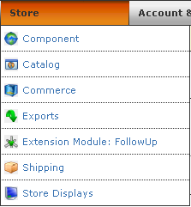

Welcome to the “money” section of ClickCartPro/EuropaCart. It is here that you’ll design your Product and Category pages, collect and ship your orders and make your money. As with each section of this manual, we’ll proceed as if you’re clicking on each menu item starting in the upper left and working your way down.

Component

Profile
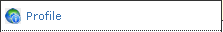

Component Name And Description

Component Name
Enter the name of the component. This name is used in all management interface displays and menus for this component. The default name is Store.

Display Name
Enter the display name of the component. This name is used in all FrontEnd displays and menus for this component. This is your name for the application within your site. If you refer to your site as the Wizbang Hammer Store, then this is what you would type in here to refer to. The default name is Online Store.

Description
Enter a description for this component. This description is used in management interface menus. This description shows up on the landing page in the Admin section that is just above the Application menu link.

Component Defaults/Component Default Status
Choose whether this component should be the default component for FrontEnd displays. Setting a default here will cause the default status for other components to be unset.

Component Default Namespace
Choose the namespace that should be displayed for this component as the default in the event that a request is received for the component without a namespace referenced.

Display Skin Override
Choose the skin that should be displayed for this component for FrontEnd displays. This skin can be overridden by namespaces and various functions within the software.

Settings

This menu handles basic settings for your site. All of the little nuts and bolts that define your site are handled by the various categories within this menu. Here you can define the web site and make it your own.

Catalog Global Displays/Settings

How do you choose to display the various lists of products your web site provides? This menu controls how you display the products in categories like “Best Sellers”, “Featured Products”, “New Items”, etc.

Your display options are identical to any product list display throughout ClickCartPro/EuropaCart. You have the following options:

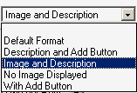

All Products: Product Display Type
If there are products to display on the store view all products page, this designation controls the display type that is used for products when viewing all products.

All Products: Products per Row
If there are products to display on the store view all products page, the designation below controls how many products are displayed horizontally when viewing all products. You have the choice of between 1 and 4 items per row.

Best Sellers: Product Display Type
If there are products to display on the best sellers page, the designation below controls the display type that is used for products when viewing the best sellers page.

Best Sellers: Products per Row
If there are products to display on the best sellers page, the designation below controls how many products are displayed horizontally when viewing the best sellers page. You have the choice of between 1 and 4 items per row.

Featured Products: Product Display Type
If there are products to display on the featured products function, the designation below controls the display type that is used for products when displaying the Featured Products page.

Featured Products: Products per Row
If there are products to display in the featured products function, the designation below controls how many products are displayed horizontally when viewing that function. You have the choice of between 1 and 4 items per row.

New Items: Product Display Type
If there are products to display on the new items page, the designation below controls the display type that is used for products when viewing the new items page.

New Items: Products per Row
If there are products to display on the new items page, the designation below controls how many products are displayed horizontally when viewing the new items page. You have the choice of between 1 and 4 items per row.

Product Index: Product Display Type
If there are products to display on in the product index, the designation below controls the display type that is used for products when viewing the product index.

Product Index: Products per Row
If there are products to display in the product index, the designation below controls how many products are displayed horizontally when viewing the product index. You have the choice of between 1 and 4 items per row.

Search Results: Product Display Type
If there are products to display on the search results page, the designation below controls the display type that is used for products when viewing search results.

Search Results: Products per Row
If there are products to display on the search results page, the designation below controls how many products are displayed horizontally when viewing search results. You have the choice of between 1 and 4 items per row.

Specials: Product Display Type
If there are products to display on the store specials page, the designation below controls which display type is used for products when viewing the specials page.

Specials: Products per Row
If there are products to display on the store specials page, the designation below controls how many products are displayed horizontally when viewing the specials page. You have the choice of between 1 and 4 items per row.

Splash Page: Categories per Row
If there are categories to display on the store splash page, the designation below controls how many categories are displayed horizontally when viewing the splash page. You have the choice of between 1 and 4 items per row.

Splash Page: Category Display Type
If there are categories to display on the store splash page, the designation below controls the display type that is used for categories when viewing the splash page.

Splash Page: Number of Featured Products to Display
Select the number of featured products to display in the featured products listing. You have the choice of between 1 and 20 items to display.

Splash Page: Product Display Type
If there are products to display on the store splash page, the designation below controls which display type is used for products when viewing the splash page.

Splash Page: Products per Row
If there are products to display on the store splash page, the designation below controls how many products are displayed horizontally when viewing the splash page. You have the choice of between 1 and 4 items per row.

Cron Settings/Settings

“Cron”; from the Greek “chronos” meaning time, is a time-based scheduling device that specifies shell commands to run periodically on a given schedule.

Last Daily Cron Run
This is the time daily cron tasks were last run for this application.

Last Weekly Cron Run
This is the time weekly cron tasks were last run for this application.

Online Order Storage Time
Select the number of years to store online orders. This defaults to 1 year, but is selectable between 1 and 5 years.

Shopping Cart/Wish List Storage Time
Select the number of months to store unmodified store shopping carts and wish lists in the database. Shopping carts and wish lists are modified each time a user adds, updates or removes an item in their shopping cart and/or wish list. This defaults to 6 months but is selectable from 1 to 12 months.

General Store Settings

This menu controls your customers’ checkout experience.

Checkout: Allow Guest Checkout
Select true to allow checkout for guest users. If checkout for guest users is allowed, an account will not be required to checkout.

Checkout: Custom Sale Method
If you have selected to activate the Custom Sale Method Status, select the custom sale method to execute during checkout.

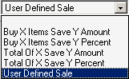

Checkout: Custom Sale Method Status
Select true to activate a custom sale method during checkout. If you select to activate a custom sale method during checkout, the Custom Sale Method specified on this page will be executed.

Checkout: Custom Surcharge Method
If you have selected to activate the Custom Surcharge Method Status, select the custom surcharge method to execute during checkout below.

Checkout: Custom Surcharge Method Status
Select true to activate a custom surcharge method during checkout. If you select to activate a custom surcharge method during checkout, the Custom Surcharge Method specified on this page will be executed.

Checkout: Display Progress Indicator
Select true to display a progress indicator in checkout.

Checkout: Minimum Order Amount
Enter a minimum order amount below. If you enter an amount greater than zero, users attempting to checkout with a total of items in their shopping cart less than the amount specified will be presented with a message indicating they need to add more items to their cart to checkout. Set to '0.00' to turn off.

Checkout: Order Number Prefix
If you select a prefixed Order Number Type, enter an order number prefix here. This prefix will be appended to all order numbers.

Checkout: Order Number Type
Select the type of order number generated by this software for online orders.

Continue Shopping: Target
Select the location to be targeted by the Continue Shopping button on the shopping cart page. When history data is available this location will be targeted.

Disable Breadcrumbs
Select true to disable breadcrumb displays. Breadcrumbs show a trail of categories to customers.

Disable Online Store
Select true to disable the online store for maintenance, or false to open the store for business.

Disable Wish List
Select true to disable wish list displays and functions.

Display Product Numbers
Select true to display product numbers for items, or false to not display product numbers.

Display Product Options With Line Breaks
Select true to display product options with line breaks, or false to display without them.

Product Page: Display Email A Friend Link
Select true to display a link on the product detail page to email a friend about the item being viewed, or false to not display the link.

Product Page: Display Related Products
Select true to display related products on the product detail page, or false to not display related products.

Shopping Cart: Allow Fractional Quantities
Select true to allow for fractional quantities in the shopping cart.

Shopping Cart: Display Images
Select true to display images in the shopping cart. Images will be displayed if at least one item has a valid image and this setting is true.

Store Pages: Products To Display per Page
Select how many products should be displayed per page by default.

Store Pages: Show Sort Options
Select true to display product sort options to users who are browsing the online store.

Image Specifications

This menu is the master control for all of the various images you display on your site. In most cases, the defaults are best to use, but if you have images you want to keep as they are, simply type a “0” in any of the values and the image will be sized exactly as you enter it.

Image Width: Cart Product Images
Enter a width in pixels to use to control the size of small product images displayed by this software in the shopping cart. Enter '0' to show all images at their actual size.

Image Width: Category Images
Enter a width in pixels to use to control the size of category images displayed by this software. Enter '0' to show all images at their actual size.

Image Width: Large Product Images
Enter a width in pixels to use to control the size of large product images displayed by this software. Enter '0' to show all images at their actual size.

Image Width: Shipping Carrier Images
Enter a width in pixels to use to control the size of shipping carrier images displayed by this software. Enter '0' to show all images at their actual size.

Image Width: Small Product Images
Enter a width in pixels to use to control the size of small product images displayed by this software. Enter '0' to show all images at their actual size.

Intershipper Settings

Intershipper is a shipping company which helps your customers find the best pricing for a particular shipment. They claim to reduce the number of abandoned shopping carts that plague most web stores by searching your particular shipping options and finding the best carrier for a particular shipment. There is some sort of fee associated with the service. If you’re interested in reading more, check out www.intershipper.com.

Settings/Active Carriers
Select which carriers should be used for Intershipper rate requests. All available carriers are listed in this box. At least one must be active. Currently, you can make the choice of UPS, USPS or FedEx.

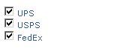

Language Strings

This menu controls the various language strings as well as their text components used throughout ClickCartPro/EuropaCart. From here you can identify and augment the text components of any string.

Linkpoint API Settings

Linkpoint is the gateway between your system and the credit card processing gateways. The contents of the API key file you downloaded from Linkpoint need to be entered into this field. This key file should be associated with your Linkpoint API-enabled account.

PayPal Website Payments Pro Settings

API Login: User Name
Enter your PayPal Website Payments Pro API username that was provided to you by PayPal.

API Login: User Password
Enter your PayPal Website Payments Pro API password that you selected for your API username.

API URL
This is the API URL used by this software to connect to the PayPal Website Payments Pro SOAP server.

Currency Code
Enter the three-letter currency code of the currency you wish to use for PayPal Website Payments Pro payments. This currency code should be the same as the the currency you've used to enter your products in the Catalog Manager. Examples: USD, GBP, CAD, JPY, etc.

Enable PayPal Website Payments Pro Express Checkout Link
Select true to activate the PayPal Website Payments Pro Express Checkout Link. If you choose to display this link, the 'PayPal (Pro Express Method) - Payment Form' payment method must also be activated for the link to be shown. PayPal requires the use of the Express method if you also choose to use the Direct method.

Keyfile Contents (API Keyfile)
The contents of the API key file you downloaded from PayPal (cert_key_pem.txt) need to be entered into the field below. This key file should be associated with the API Password you enter on this page.

Peachtree Export Settings

This menu manages all of your company’s account information so that you can accurately export your files directly into your Peachtree accounting software.

Account Number: Accounts Receivable
Enter the account number for the accounts receivable account.

Account Number: Country Tax Amount (Income)
Enter the account number for the income account associated with the country tax total.

Account Number: Discount Amount (Expense)
Enter the account number for the expense account associated with the discount total.

Account Number: Item Subtotal (Income)
Enter the account number for the income account associated with the order subtotal.

Account Number: Payment (Bank or A/R)
Enter the account number for the bank or accounts receivable account.

Account Number: Sale Amount (Expense)
Enter the account number for the expense account associated with the sale total.

Account Number: Shipping Amount (Income)
Enter the account number for the income account associated with the shipping total.

Account Number: State/ Province Tax Amount (Income)
Enter the account number for the income account associated with the state/province tax total.

Invoice Display Name: Country Tax Amount
Enter the invoice display name for the country tax total.

Invoice Display Name: Discount Amount
Enter the invoice display name for the discount total.

Invoice Display Name: Payment
Enter the invoice display name for the payment.

Invoice Display Name: Sale Amount
Enter the invoice display name for the sale total.

Invoice Display Name: Shipping Amount
Enter the invoice display name for the shipping total.

Invoice Display Name: State/Province Tax Amount
Enter the invoice display name for the state/province tax total.

Invoice Display Name: Surcharge Amount
Enter the invoice display name for the surcharge total.

Tax Type: Country Tax Amount
Enter the tax type for the country tax total.

Tax Type: Country Tax Refund Amount
Enter the tax type for the country tax refund total.

Tax Type: Discount Amount
Enter the tax type for the discount total.

Tax Type: Item Subtotal
Enter the tax type for the item subtotal.

Tax Type: Payment
Enter the tax type for the payment.

Tax Type: Sale Amount
Enter the tax type for the sale total.

Tax Type: Shipping Amount
Enter the tax type for the shipping total.

Tax Type: State/Province Tax Amount
Enter the tax type for the state/province tax total.

Tax Type: Surcharge Amount
Enter the tax type for the surcharge total.

Quickbooks Export Settings

This menu manages all of your company’s account information so that you can accurately export your files directly into your Quickbooks accounting software.

Settings/Account Name: Accounts Receivable (A/R)
Enter the account name for the accounts receivable account.

Account Name: Bank Account (Bank)
Enter the account name for the bank account to which amounts should be posted.

Account Name: Country Tax Amount (Income)
Enter the account name for the income account associated with country tax charges.

Account Name: Country Tax Refund (Expense)

Account Name: Discount Amount (Expense)
Enter the account name for the expense account associated with the order discount amount.

Account Name: Item Subtotal (Income)
Enter the account name for the income account associated with the item subtotal.

Account Name: Sale Amount (Expense)
Enter the account name for the expense account associated with the order sale amount.

Account Name: Shipping Amount (Income)
Enter the account name for the income account associated with shipping charges.

Account Name: State/Province Tax Amount (Income)
Enter the account name for the income account associated with state/province tax charges.

Account Name: Surcharge Amount (Income)
Enter the account name for the income account associated with the surcharge total.

Invoice Display Name: Country Tax Amount
Enter the invoice display name for the country tax amount.

Invoice Display Name: Country Tax Refund Total
Enter the invoice display name for the country tax refund amount.

Invoice Display Name: Discount Amount
Enter the invoice display name for the discount amount.

Invoice Display Name: Sale Amount
Enter the invoice display name for the sale amount.

Invoice Display Name: Shipping Amount
Enter the invoice display name for the shipping amount.

Invoice Display Name: State/Province Tax Amount
Enter the invoice display name for the state/province tax amount.

Invoice Display Name: Surcharge Amount
Enter the invoice display name for the surcharge amount.

Remote E-Commerce Settings

Perhaps you have an existing site and don’t want to convert it all to a database format? You can activate this feature and simply add “Add To Cart” buttons that link your shopping cart to your current site. Here you would outline the additional sites that would be using your shopping cart.

Allow Remote Product Page POSTs
Select below to allow remote product page POSTs. When set to true, product pages from remote URLs will be allowed to post product information into the e-commerce shopping cart. When set to false, this functionality is disabled.

Allowed Remote Product Page URLs
Enter a single or comma separated list of URLs for remote product pages allowed to POST into the e-commerce shopping cart. These URLs can be entered as partial URLs or fully qualified URLs. Pattern matching is performed on referrer information based on the URLs entered here to determine whether a remote product page is allowed to post into the e-commerce shopping cart. If this field is empty and you have selected to Allow Remote Product Page POSTs, no remote product pages will be allowed to POST into the e-commerce shopping cart.

Shipping Settings

This menu handles all things shipping. Here you can customize your customer’s shopping and shipping experience.

Add Handling Charge To Free Shipping Methods
Set this field to true to add handling charges to free shipping methods. Set this field to false to prevent handling charges from being added to free shipping methods.

Allowed Shipping Addresses
This software can allow a customer to ship their order to multiple addresses, a single address or to their billing address only. Select the appropriate option to control the type and number of addresses allowed for shipping.

Free Shipping Threshold
Want to offer free shipping on all orders over $100? Enter a free shipping threshold below. If you enter an amount greater than zero, the lowest value for all shipping methods will be free of charge, and the amount for that lowest value will be subtracted from all other shipping options presented. Set to '0.00' to turn off.

Handling Charge
Enter a handling charge below. If you enter an amount greater than zero, the handling charge specified will be added to the cost for each shipment. Set to '0.00' to turn off.

Realtime: Minimum Box Height
Enter a minimum height for boxes to be shipped via realtime carriers. If a box is presented to the shipping module with a height below this minimum, the minimum specified here will be used.

Realtime: Minimum Box Length
Enter a minimum length for boxes to be shipped via realtime carriers. If a box is presented to the shipping module with a length below this minimum, the minimum specified here will be used.

Realtime: Minimum Box Weight
Enter a minimum weight for boxes to be shipped via realtime carriers. If a box is presented to the shipping module with a weight below this minimum, the minimum specified here will be used.

Realtime: Minimum Box Width
Enter a minimum width for boxes to be shipped via realtime carriers. If a box is presented to the shipping module with a width below this minimum, the minimum specified here will be used.

Realtime: Present Dimensional Error Notices
If the dimensions of a shipment are above the maximum dimensions allowed by a realtime carrier and an error is produced as a result, in addition to using the Shipping Error Carrier Name and Amount for the rate, a notice can be presented by this software. If you set this to “True” this notice will be presented. “False” will suppress this notice.

Realtime: Present Weight Error Notices
If the weight of a shipment is above the maximum weight allowed by a realtime carrier and an error is produced as a result, in addition to using the Shipping Error Carrier Name and Amount for the rate, this software can present a notice. If you set this to “True” this notice will be presented. “False” will suppress this notice.

Return Currency: FedEx
Select the currency used by FedEx to return shipping rates for your FedEx account.

Return Currency: USPS
Select the currency used by USPS to return shipping rates for your USPS account.

Shipping Error: Amount
Enter a shipping error amount below. In the event of an error calculating shipping, this charge will be displayed to the customer.

Shipping Error: Carrier Name
Enter a shipping error carrier name below. In the event of an error calculating shipping, this carrier name will be displayed to the customer.

XMOD Settings
Here you will find your current XMODs that have settings listed and available for you to adjust.

Catalog

The Getting Started Guide covered the best way to add multiple Categories, Products and Options en masse when you begin to set up your web site. Once you’ve set up your initial store using the Getting Started Guide, this interface will be the place where you add these items one at a time.

As you begin to add new products and categories to your site, you’ll notice that you will need to enter unique identifiers for each individual product and category. These identifiers reside in the background and are never seen by your customers. Product identifiers are used in conjunction with related products and categories when the web site identifies a certain product. Because there is a set length of 250 characters for each product entry, it is best to abbreviate your product names and keep this system as simple as possible. This can be especially useful if you plan on having many sub-categories to reference.

Every item in the Catalog Heading offers you the ability to Add a completely new item, Delete an unwanted item or Clone an existing item. The menu is designed in a logical order. You first create a Category, Product Option Items, and Product Options…all before you create a product.

Why? Simple, because when you start creating a new product, it will ask you what category you want it in and what product options you want to include…if you haven’t created these items yet, this could be difficult.

Categories
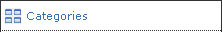

This is where you will setup and maintain the main categories of your web site. These categories will be displayed in the Categories portion of your web site’s main menu and will lead your customers through the main highlights of your site. You will augment this section to reflect your web site’s personality and theme.

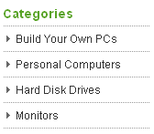

Important Note:
You can now do a quick audition of any category page by simply clicking on the Audition Category Link located on the Categories page.

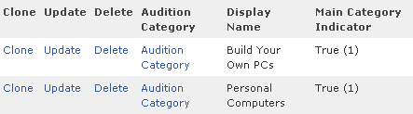

To begin adding categories, simply click on the Insert link under the Functions Menu.

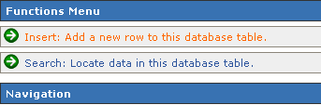

The page that comes up contains the following fields, which will help you create a new category:

Category

Identifier
This identifier is used within the software to specify this category. Because this identifier is used in XHTML form fields, do not use spaces, periods or special characters. Recommended characters are 0-9, a-z, A-Z and the underscore character.

Display Name
This is the display name for this category. This display name is used in meta tags generated by the software. This is also the name that will appear on the menu in your web site. It should identify your category clearly so that your customers know what is there.

Description
This description is used in meta tags generated by the software. This is a description for this category. It can be the text that shows up when a person searches and finds you in a search engine. Be sure to take the time to best describe and sell your product here. The work you do here can be cumbersome, but usually yields dividends by increasing traffic to your site. Choose your words and your descriptions carefully. This helps interested customers locate and learn about your products before they arrive at your web site. Think of them as “smart” road signs. If they’re misleading, customers may never find your store. This description will also be used in the event that you select this category as a sub-category of a larger main category to briefly summarize the contents.

This description can contain XHTML tags. XHTML is a stricter version of HTML, the code that most web pages are made from.

If you go to a web page and in your web browser, tell it to View Source, you will see HTML or XHTML. XHTML tags tell the browser that you might want a word to be bold. In order for the word “bold” to show up “bold”, the XHTML code would look like this (<b>bold</b>)) If the description contains XHTML tags, be sure to set the Description Contains XHTML Tags field to true.

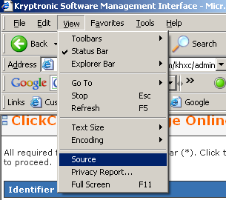

Important Note:

All Kryptronic products now contain a WYSIWYG (What You See Is What You Get) editor on fields that contain XHTML code. Why is this, you may ask? Now, text entries can be automatically converted to XHTML by simply typing them into this field and then clicking on the Bold/Italic/Underline and other text tools just like you do in a word processor. The software now just converts it for you so you don’t have to learn basic HTML programming. To launch the WYSIWYG editor just click on the blue WYSIWYG Editor: Load Editor link located in the various appropriate fields. It will launch the WYSIWYG toolbar that looks like this:

Category Image
This image is used in category displays. It is normally situated to the left of the Category title and description. It is also displayed if you set you category listings to include a picture…both examples are shown below:

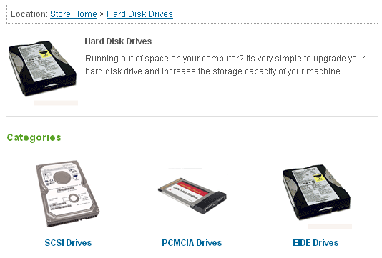
To add a new image, you can either enter the name or browse your hard disk and upload a specific file.

To associate a file with this item, either enter a file name or use the file upload field to download a file from your hard disk. Just hit the Browse button and find the file on your disk…when you’re finished with this category and hit the Submit button at the bottom of the page, the software will automatically upload this file to the appropriate directory on your web site.

Important Note:
When using the Admin interface to set up your categories, the interface automatically copies your category images to a directory in the /media/ccp0/cat folder on your server. If you decide to load your category photos en masse using a spreadsheet, just use your favorite FTP editor to load the pictures into this folder.

Main Category Indicator
This indicator when set to true treats this category as a main category to be displayed on the online store splash (intro) page. If it is set to false, this category is to be considered a sub-category of another category. This can be assigned via the Related Categories menu that is covered on the bottom of this page. Related Categories appear within the main page of any Main Category.

Sort Order
This sort order numeric allows display of categories in a particular order. Categories are sorted within displays in ascending order based on this numeric indicator.

Meta Tags

Meta Keywords
Enter a comma-delimited list of keywords below. These keywords are used in both software searches and meta tags generated by this software. This is one of the major keys to establishing your site on search engines, so be thorough, specific and choose your words wisely.

Important Note:
When jotting down your keywords, make sure you really focus on different ways to describe your product. For example, if you sell records, you may also want to use words like LP, 45, 33, discs, wax pressings, etc. Sometimes, a thesaurus can show you alternative words to describe your product. Different countries, and even different parts of the same country refer to things differently. Denoting all of these in your keywords can help you be more easily found when customers come calling.

Display

Display Skin
Choose the skin that should be displayed for this category. If you do not select a skin to display, the application or namespace default skin will be used.

Like HTML programming, creating your own skin can be pretty tricky business. There is a skin adjustment tutorial listed in the Getting Started Guide. It will help you get your site up and running quickly and easily. For a detailed and more complex site, you may save yourself a great deal of heartache by hiring an expert either locally or at salesdesk@kryptronic.com.

Sub-Categories To Display per Row
If you’ve created sub-categories to be placed within your main categories, you will choose here how many to display horizontally per row. You have choices ranging from one sub-category per horizontal row to four sub-categories.

Sub Category Display Type
This entry allows you to select how your sub-categories are displayed. The default display method shows a thumbnail (small) image and a title. You can also choose both a thumbnail image and description or simply a title and description with no image.

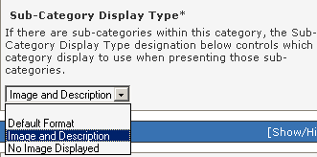

Products to Display Per Row
If there are products within this category, the Products to Display per Row designation below controls how many products are displayed horizontally when viewing this category. Like the Category indicator, you can choose between one and four products per horizontal line.

Product Display Type
If there are products within this category, the Product Display Type designation controls which product category view display to use when presenting those products. Also like the category display, you can choose from the following:

Default
Displays Title and Image
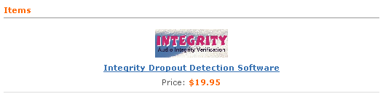

Description and Add Button
Displays Title, Image, Description, Quantity and an Add Button.

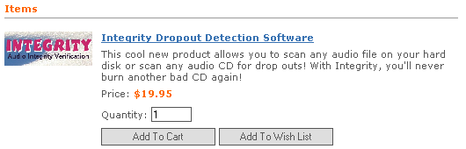

Image And Description
Displays Title, Image and Description

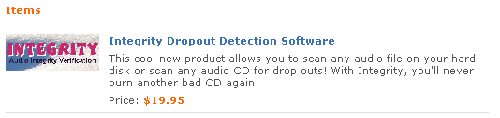

No Image
Displays Title and Description

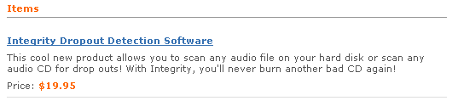

With Add Button
Displays Title, Image and Add Button

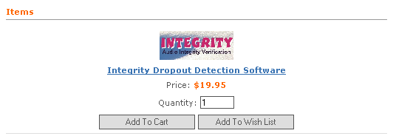

Product Multi-Add Indicator
This field allows you to control whether this category uses a product multi-add display. If this field is set to true, the product display type and number of products to display per row values for this category are ignored. Instead of using those values to display products for this category, this category will present a display list that allows a user to add multiple products to their shopping cart or wish list from the category page.

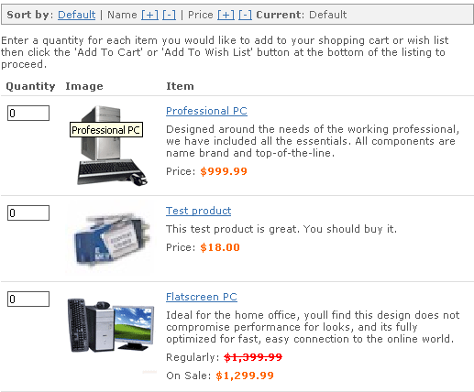

Related Categories
Related categories are displayed as sub-categories of this category in the main page of each category. Just check the appropriate sub-categories related to this category.

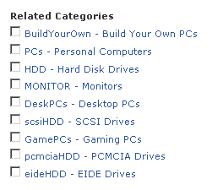

Visibility

Visibility Selection
This field allows you to control the users who can view this category. You can set this category up to be viewed by everyone, only users belonging to the groups you specify using the Category Visibility Groups field, or to be hidden from everyone.

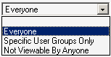

Category Visibility Groups
If you select Specific User Groups Only, then this checkbox allows you to specify who those specific groups should be. Just check the groups you want to include for this category. Here are your visibility choices:

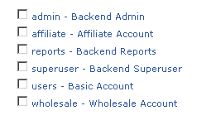

Option Selection Items

This heading allows you to manage all of the options you may present for particular products. If you sell computers and each computer allows you to pick certain mice, video cards, DVD ROMS, and other options, you would list those items here. They would then show up as options after your customer selects the base item. This section also allows you to assign a positive or negative adjustment to the overall package so that the price to the customer changes “on the fly”.

These are the actual Product Option items themselves. This is where you spell out the product; it’s details and additional cost. Once you have determined the individual items, you will then use the next field, “Manage Product Options” to categorize the products into groups like “CD ROM upgrades”, “Hard Disk Upgrades”, etc.

It looks like this:
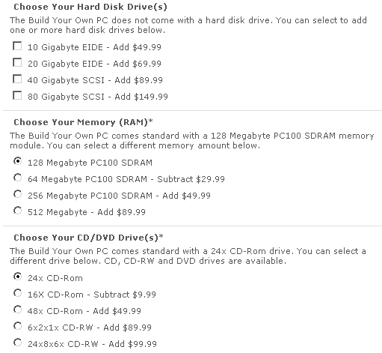

To add a new product option, simply click on the Insert link under your Functions menu. You can also edit your existing Options by clicking on the “Update” link beside the chosen product.

These options can then be added to the Related Product Options field of any included product.

Option Selection Item

Identifier and Name/Identifier
This identifier is used within the software to specify this option selection item. It is entered under the Product Options function to associate this selection item with a product option. Because this identifier is used in XHTML form fields, do not use spaces, periods or special characters. Recommended characters are 0-9, a-z, A-Z and the underscore character. Your customers do not see it, so it can be abbreviated for your convenience.

Display Name
This is the display name for this product option selection item. It is used in displays to identify the selection item. Make sure you name this option concisely so customers easily understand the various options they can add.

Inventory Level
You may also want to track the stock of your product option items. This is similar to the declining balance of your product inventory. If you want this to track, simply add the number of products currently in stock. Inventory will be adjusted according to your customer orders. Also remember to manually adjust the quantity for phone or manual orders. Otherwise, this product option will not be available for purchase from your customers if it shows a “0” balance. Enter the inventory level for this product option selection item below. Declining Balance Inventory must be activated for product options this product option selection item is associated with in order to ensure inventory is declined when this product option selection item is ordered. The default is zero ('0').

Item Sort Order
The item sort order numeric allows display of all the product option selection items associated with a product option in a particular order. The product option selection items are sorted in ascending order based on this numeric indicator. The first product you want will be assigned “0” and on up throughout your list.

Price Adjustments

Base Price Change
As customers add and delete options, the overall price of the product can flow with their changes automatically. Enter a base price change for this product option selection item. This base price change will affect the one-time base price for items added to customer shopping carts with this product option selection item. You can enter a positive number (Example: Enter '+1.00' or '1.00' to increase the base price) or a negative number (Example: Enter '-1.00' to decrease the base price). If you enter '0.00' or a zero-equivalent, this product option selection item will have no effect on pricing of options or items.

Recurring Price Change
Enter a recurring price change for this product option selection item. This recurring price change will affect the recurring price for items added to customer shopping carts with this product option selection item. You can enter a positive number (Example: Enter '+1.00' or '1.00' to increase the recurring price) or a negative number (Example: Enter '-1.00' to decrease the recurring price) or nothing at all. If you enter '0.00' or a zero-equivalent, this product option selection item will have no effect on pricing of options or items.

Wholesale Price Change
Enter a wholesale price change for this product option selection item. This wholesale price change will affect the wholesale price for items added to customer shopping carts with this product option selection item. You can enter a positive number (Example: Enter '+1.00' or '1.00' to increase the wholesale price) or a negative number (Example: Enter '-1.00' to decrease the wholesale price). If you enter '0.00' or a zero-equivalent, this product option selection item will have no effect on pricing of options or items.

Affiliate Commission Change
Enter an affiliate commission change for this product option selection item. This affiliate commission change will affect the affiliate commission for items added to customer shopping carts with this product option selection item. You can enter a positive number (Example: Enter '+1.00' or '1.00' to increase the affiliate commission) or a negative number (Example: Enter '-1.00' to decrease the affiliate commission). If you enter '0.00' or a zero-equivalent, this product option selection item will have no effect on affiliate commissions of options or items.

Weight Adjustments

Weight Change
Obviously, as you add options to a base product, you also affect the overall weight of your shipment. This field allows you to adjust the shipping weight of the product as options are added. Enter a weight change for this product option selection item. This weight change will affect the overall weight for items added to customer shopping carts with this product option selection item. You can enter a positive number (Example: Enter '+1.000' or '1.000' to increase the weight) or a negative number (Example: Enter '-1.000' to decrease the weight). If you enter '0.000' or a zero-equivalent, this product option selection item will have no effect on overall weight of options or items.

Digital Download

Download File
A download file can be associated with this product option selection item. If you choose to associate a file with this item, the file will be made available for download by customers who place an order for this product option selection item.

To associate a file with this item, either enter a file name or use the file upload field to download a file from your hard disk. Just hit the Browse button and find the file on your disk…when you’re finished with this product option and hit the Submit button at the bottom of the page, ClickCart Pro will automatically upload this file to the appropriate directory on your web site.

Taxes
Apply State and Province Tax
Indicate if state and province taxes are applicable to this product option selection item.

Apply Country Tax
Indicates if country taxes are applicable to this product option selection item.

Tax Classification
Select the classification for tax purposes for this product option selection item. Product option selection items classified other than Standard may be subject to special tax treatment.

Product Options
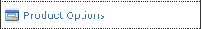

Now that you’ve set up your individual product option items in the proceeding fields, it’s time to group these items into categories and assign them a certain look and feel for their display. As always, you can choose an existing Product Option Category to edit or add a new category by clicking on the “Insert: Add a new row to this database link” in your Functions Menu.

Product Option

Identifier
This identifier is used within the software to specify this product option. It is entered under the Products function to associate this option with a product. Because this identifier is used in XHTML form fields, do not use spaces, periods or special characters. Recommended characters are 0-9, a-z, A-Z and the underscore character.

Display Name
This is the display name for this product option. It is used in displays to identify the option to the customer.

Description
Enter a description for this product option to be displayed to customers. This description can give them instructions. This description can contain XHTML tags. If the description contains XHTML tags, be sure to set the Description Contains XHTML Tags field to true. This is where you simply describe the option and instruct the customer the various choices available.

Important Note:

All Kryptronic products now contain a WYSIWYG (What You See Is What You Get) editor on fields that contain XHTML code. Why is this, you may ask? Now, text entries can be automatically converted to XHTML by simply typing them into this field and then clicking on the Bold/Italic/Underline and other text tools just like you do in a word processor. The software now just converts it for you so you don’t have to learn basic HTML programming. To launch the WYSIWYG editor just click on the blue WYSIWYG Editor: Load Editor link located in the various appropriate fields. It will launch the WYSIWYG toolbar that looks like this:

Form Field Type
This is the XHTML form field type used to display this product option. If you select a field type of Selection, Checkboxes or Radio Buttons, be sure to enter the ID for at least one option selection item below.

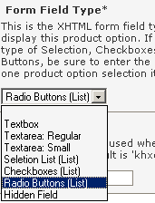

You can choose a Text Box:

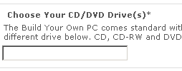

A Text Area: Regular

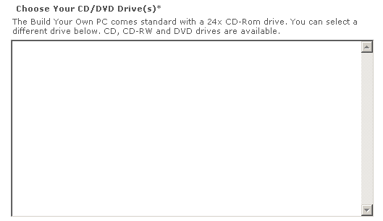

A Text Area: Small
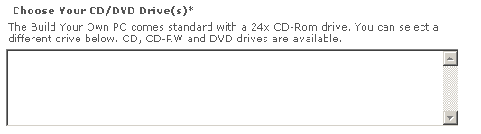

A Selection Area:
Note: You must list these items in the Related Product Option Selection Items field that follows.

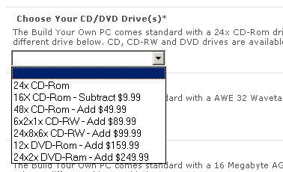

Checkboxes:
Note: You must list these items in the Related Product Option Selection Items field that follows.

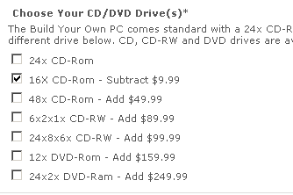

Radio Buttons:

Note: You must list these items in the Related Product Option Selection Items field that follows.

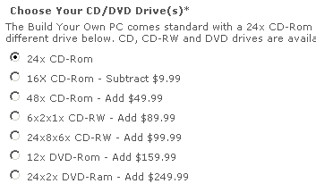

Hidden Field:
This simply removes the selection from this page.

Required Indicator
Must these options be addressed in order for the customer to order the associated product? If yes, set this indicator to “True”, if no, set this indicator to “False”

Declining Balance Inventory
For field types of Selection, Checkboxes or Radio Buttons you can specify inventory on the product option selection item level. If you would like to activate a declining balance inventory for those selection items, set this value to true. To turn off declining balance inventory, set this value to false. If you use Declining Balance Inventory and the system thinks a product is not in stock, it will no present it to the customers. This can be a two-edged sword. It is very nice to present an accurate message about stock to your customers, but in many cases, customers will look elsewhere if they can’t find what they’re looking for. After they’ve placed an order, most customers will accept a message telling them their order will ship in a few days.

Option Sort Order
This allows you to display all of the product options associated with a product in a particular order. The product options are sorted in ascending order based on this numeric indicator. Your first option would be labeled “0” and on up through all of the options.

Option Section
The name of the section of the option display form this option should be printed in. To create a new section, simply enter in a section that has not yet been used.

Related Option Selection Items
Here you will see a checklist of all of the Product Option Selection Items you created in the previous section. Just click on the ones you want included in this option. For example, if you created a Product Option called Upgrade Your Hard Disk, you would simply add all of your Product Option Selection items that are hard disk upgrades. You must enter at least one product option selection item ID if the Form Field Type above is set to Selection, Checkboxes or Radio Buttons.

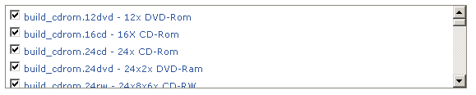

Products
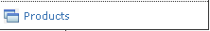

Here is where you will control the content and visual presentation of your actual products. You will enter images, descriptions, category listings, prices, costs, related products and virtually any important product-specific information. When you click on this item in your menu, you will be presented with the ability to add new products or edit your existing product list.

Important Note:
If you want to quickly audition any product page, simply click on the Audition Product link located on the Store:Products page.

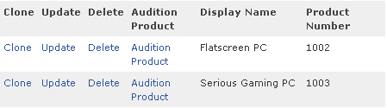

Product

Identifier
This identifier is used within the software to specify this product. Because this identifier is used in XHTML form fields, do not use spaces, periods or special characters. Recommended characters are 0-9, a-z, A-Z and the underscore character.

Display Name
This display name is used in Meta tags generated by the software. It can be the text that shows up when a person searches and finds you in a search engine. Be sure to be careful when adding the name of the product here. Always be cognizant of the fact that search engines are the judge of how well you get inside your customer’s head. This extra thought usually yields dividends by increasing traffic to your site. Choose your words carefully. Even something as simple as a product name can be thought of as a lighted sign pointing to your store.

Product Number
This is the product number. This number is used in some displays to identify the product. This product number is also available for searches. It is an easy way to track products with similar or identical names, much like bar codes do in a retail store.

Meta Keywords
Enter a comma-delimited list of keywords. These keywords are used in both software searches and meta tags generated by this software. As always, these keywords can be signposts in search engines to point customers to your site. Be smart and thorough when making these decisions.

Short Product Description
Enter a short product description in this field. This short description must not contain XHTML tags. This description is used in category displays and to generate Meta tags. This description should sum up your product in a few sentences. It is used in the category lists of products.

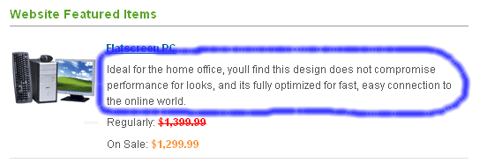

Long Product Description
This is the long detailed product description. It will be inserted in the product page. This description can contain XHTML tags. If the description contains XHTML tags, be sure to set the Description Contains XHTML Tags field to true.

Important Note:

All Kryptronic products now contain a WYSIWYG (What You See Is What You Get) editor on fields that contain XHTML code. Why is this, you may ask? Now, text entries can be automatically converted to XHTML by simply typing them into this field and then clicking on the Bold/Italic/Underline and other text tools just like you do in a word processor. The software now just converts it for you so you don’t have to learn basic HTML programming. To launch the WYSIWYG editor just click on the blue WYSIWYG Editor: Load Editor link located in the various appropriate fields. It will launch the WYSIWYG toolbar that looks like this:

Confirmation Email Text
You can enter text below to be included in order confirmation messages for orders containing this product. Do not enter XHTML tags in this confirmation email text. You’ll normally have a standard email address that ships to your customers for every order you ship out of the store. This message is for products that may require special attention or instructions to deliver your customers the most useful and up to date information available.

Product Sort Order
This sort order numeric allows display of products in a particular order. Products are sorted within category and related product displays in ascending order based on this numeric indicator. Products are listed from 0 and up to determine their placement in a particular category. (what do you do if you have a product that you want #1 in one category, but #6 in another?…two products made?)

Product Index Group
This product index selection controls under which letter in the index this product is displayed in. Simply match the first letter of the product. This is not done automatically, so make sure you don’t skip this step when setting up your product. (Apples go under “A”)

Pricing

Pricing Type Selection
This is the pricing type for the product. This product can be priced regularly, on sale, option based (all prices come from options only), volume based, use only a recurring charge or not be priced at all (not for sale - display only). After choosing the most appropriate option for this product, you can then configure the details in the fields that follow.

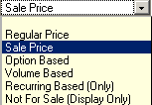

Regular Price
This is the regular base price for the product. This price is used for the 'Regular Price' and 'Sale Price' pricing types. Enter as '0.00' if you are not using this paradigm.

Sale Price
This is the sale price for the product. This price is used for the 'Sale Price' pricing type. Enter as '0.00' if not used.

Volume Price Schema
If you have selected Volume Pricing for your Pricing Type above, then this is the formula you will display to determine volume pricing. Here is an example of how to enter this schema:

1:14.00; 2-5:12.00; 6-9999:10.00

(This basically means “1 unit is $14.00, 2-5 units are $12.00 each and 6-9999 units are $10 each.)

Important Note: Make sure you have Volume Pricing selected above. Remember, you also need to fill in the next space, which is an html description of the pricing you’ve displayed. This doesn’t have to be anything fancy. We’ll show you how in the example.

Volume Price XHTML Description
This is the volume pricing XHTML description for the volume pricing schema above. This XHTML description is used for the 'Volume Based' pricing type. This description should be written in standards compliant XHTML. This is what is shown to the customer to explain the schema above. You can enter either literal prices here, or enter prices wrapped in 'price' XML tags to use the currency conversion system. Example: <price>100.00</price>. Follow these exact guidelines or your pricing will only show as 0.00.

Your HTML code would look like this:

<p>For one unit, the price would be <price>14.00</price>, 2-5 units would be <price>12.00</price> and 6-9999 units would be <price>10.00</price></p>

We use the <price> identifier in the HTML code so that if something other than US dollars are used, it is automatically converted.

Recurring Price
If you have a monthly service or subscription, this needs a recurring price for the product. This price is used for the 'Regular Price', 'Sale Price' and 'Recurring Based (Only)' pricing types. Enter as '0.00' if not used.

Wholesale Price
This is the wholesale price for the product. This price is used for the 'Regular Price' and 'Sale Price' pricing types for wholesale account holders. Typically this price is less than the regular and sale prices.

Important Note About Affiliate and Wholesale Pricing:

If you plan on offering Affiliate and Wholesale pricing in your store, you’ll also need to activate these systems in the Core.

Just go to the Core and select Settings

Then select the Wholesale and Affiliate Account Settings.

You’ll now be able to activate the various programs you wish to offer and also be able to set limits for commissions. You should also remember that if you plan to offer both Affiliate and Wholesale pricing on all of your products and you used our Getting Started Guide to set up the majority of your products, you’ll need to fill in Affiliate and Wholesale pricing on your spreadsheet for both the products and product options.

Affiliate Commission Amount
If you have an affiliate dealer who is given a certain amount per product to sell your products, this is where you would enter that pricing for each product. Enter an amount to pay as commission to affiliates that generate orders for this product. Enter '0.00' to suppress payment of affiliate commissions for this product.

Product Sort/Search Price
The product sort/search price controls how this product is displayed in FrontEnd result sets when sorted by price. It also controls the price used in store searches when a minimum or maximum price is entered by the user. Enter a price here to use for this sort. This price is not used by the software for any calculations.

A good price to use here would be the actual price for a quantity of one of this product. This field is stored as an integer in the database without a decimal to ensure accurate sorting.

Example:
$999.85 would be stored as $999 or $1000

Display

Display Skin
Choose the skin that should be displayed for this product. If you do not select a skin to display, the application or namespace default skin will be used.

Product Display Type
The Product Detail Display Type designation controls which product detail view display to use when presenting this product.

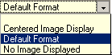

Default Format places your image to the left and description and price on the right, like this:

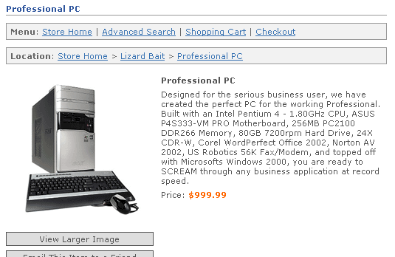

Centered Image Display looks like this:

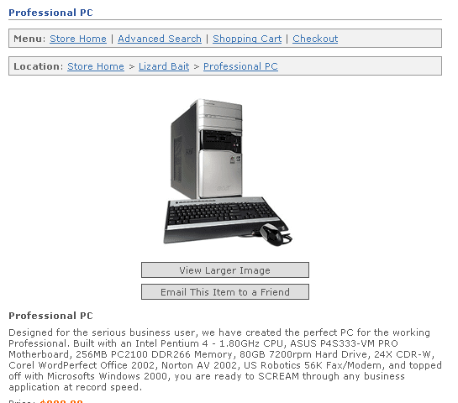

No Image Displayed looks like this:
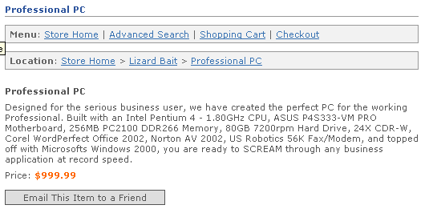

Related Product Display Information

Related Products Display Type
Much like your category pages, if there are products to display that are related to this product, this designation controls which display type is used for related products when viewing this product.

Related Products Per Row
If there are products to display as related to this product, this designation controls how many related products are displayed horizontally when viewing this product. You can choose between one and four products depending on the visual style you prefer.

Related Product Multi-Add Indicator
This field allows you to control whether this product uses a product multi-add display for related products. If this field is set to true, the related product display type and number of related products to display per row values for this product are ignored. Instead of using those values to display related products for this product, this product will present a display that allows a user to add multiple related products to their shopping cart or wish list from the product page. An example of the Multi-Add indicator was covered during the Category tutorial earlier in this manual.

Display on Store Splash Page
What are the first products you want a customer to see? Setting this dropdown menu to “true” will display the product you’re working on right on your web site’s front page.

Display on New Products Page
Set the dropdown menu to “true” if you want to display the product you’re working on within the online store New products page. This is a great category for repeat customers so that they can quickly peruse only those items new to your store that they may not be familiar with.

Display On Specials Page
There is no better promotion on this planet than the special. Set this dropdown menu to “true” so the product you’re working on is displayed on your Specials page. Customers are much more likely to return to a site where they think they have received special pricing and superior service.

Display On Best Sellers Page
Set the dropdown menu to “true” to add this product to your Best Sellers page. This page is good for customers who are having difficulty making a decision about a certain product. The “Best Seller” distinction lets them feel like they are making a popular decision. This is based on the all-important “Lemming Theory”.

Display in Featured Products Function
Indicate whether to display this product in the featured products function. Up to five products can be displayed in this function.

Images

Small Product Image
This image is used in category displays for this product as a thumbnail image.
If there is a file shown in this box, it is currently the thumbnail image associated with this item. If you wish to use a different file, you can either enter a new file name for files that are already installed on your web site, or use the Browse button to find and upload a file from your hard disk. Unlike many shopping carts that force you to create your own thumbnail, the software automatically sizes your images to the perfect size.

Important Note:
When using the Admin interface to set up your products, the interface automatically copies your small product images to a directory in the /media/ccp0/prodsm folder on your server. If you decide to load your thumbnail photos en masse using a spreadsheet, just use your favorite FTP editor to load the pictures into this folder.

Large Product Image
This image is used in detail displays for this product as a large detail image. You can upload and use a single image or enter a comma-delimited list of multiple images. If there is a file shown in this box, it is currently the large product image associated with this item. If you wish to use a different file, you can either enter a new file name for files that are already installed on your web site, or use the browse button to find and upload a file from your hard disk.

Important Note:
When using the Admin interface to set up your products, the interface automatically copies your large product images to a directory in the /media/ccp0/prodlg folder on your server. If you decide to load your product photos en masse using a spreadsheet, just use your favorite FTP editor to load the pictures into this folder.

Extra Large Product Image
This image is used in detail displays for this product as an extra large detail image accessed via a lightbox effect by default. You can upload and use a single image or enter a comma-delimited list of multiple images. If there is a file shown in this box, it is currently the extra large product image associated with this item. If you wish to use a different file, you can either enter a new file name for files that are already installed on your web site, or use the browse button to find and upload a file from your hard disk. When you include an Extra Large Product Image, your product page will include a new button that will show these photos for you. It will look like this:

Important Note:
When using the Admin interface to set up your products, the interface automatically copies your extra large product images to a directory in the /media/ccp0/prodxl folder on your server. If you decide to load your extra large photos en masse using a spreadsheet, just use your favorite FTP editor to load the pictures into this folder.

Taxes

Apply State and Province Tax
Indicate if state and province taxes are applicable to this product. Normally in the United States, state tax is applicable on products you sell to customers within your state. In most cases, if you live in Pennsylvania and sell a product to a customer in California, state taxes are waived. It is always a good idea to check with your local state tax authority if you have a question.

Apply Country Tax
Indicates if country taxes are applicable to this product. In most cases, country taxes are added to products when they arrive in the destination country and are included in the Customs process. If you have a question about such taxes, it is always good to consult with a tax authority for your country or state.

Tax Classification
Select the classification for tax purposes for this product. Products classified other than Standard may be subject to special tax treatment. Choose from

- Standard
- Digital
- Disability

Inventory

Use Declining Balance Inventory
Indicate whether to use declining balance inventory for this product. If you choose to use declining balance inventory, be sure to enter an Inventory Level. Items that use inventory and have a zero inventory level will be unavailable for purchases. This feature will keep customers from purchasing products that you don’t currently have in stock. It will also keep you from charging customers for a product you can’t ship to them and then having to reverse charges at a later time. Of course, this must be monitored closely, as you also want your customers to be able to order your products at any time.

Inventory Level
This is the inventory level for the product. This inventory level is declined for each item ordered until it reaches zero if this product is set up to Use Declining Balance Inventory. Enter as '0' if not used. This is how the software knows what you have and don’t have. It will simply remove items as customers order until “O” is reached. ClickCartPro/EuropaCart only knows when products are purchased via the store. If you also have telephone ordering available, this quantity must be updated to keep it useful.

Minimum Quantity Allowed
This is the minimum quantity allowed in customer shopping carts for this product. Customers will be unable to add item quantities less than this level. Set this value to zero to disable this feature.

Maximum Quantity Allowed
This is the maximum quantity allowed in customer shopping carts for this product. Customers will be unable to add item quantities more than this level. Set this value to zero to disable this feature.

Delivery

Delivery Method
This is the delivery method for the product. This product can be a service(not be delivered by a physical carrier), it can be delivered via realtime shipping carriers, a product specified method, a custom shipping method or it can be a digital download item.
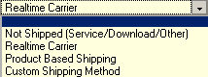
Custom Shipping: Method
If you’ve chosen a “Custom” shipping method, this field will help you decide which custom shipping method best suits your product. You can base your shipping charge on your Total Item Cost, your Total Item Quantity, Your Total Item Weight, a percentage of the total Item Cost, or define your own calculation.

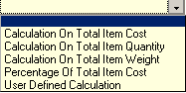

Product Based: Method Screens
These fields are used for the 'Product Based Shipping' delivery type. Enter a name below for the various product based shipping methods. You may want to bypass the realtime shippers and just offer blanket pricing on a product. This is where you would offer such a thing.

Example:

Ground Shipping- $10.00
2nd Day Shipping- $18.00
Overnight Shipping- $1000.00

Realtime Local Delivery Carrier
Here you can choose the standard realtime local (domestic) deliveries that you use. Just check all of the delivery services you are connected to and your customers will then receive realtime quotes for shipping on all of their orders. The following shippers are currently supported in ClickCartPro/EuropaCart:

- FedEx DirectConnect
- InterShipper
- UPS Online Tools
- USPS WebTools

Realtime International Delivery Carrier
This field is used for the 'Realtime Carrier' delivery type for international orders. Select one or all of the carriers that you will use. Their rates and options will be displayed to your customers after you configure the rest of your site. The following list is currently supported in ClickCartPro/EuropaCart.

- FedEx DirectConnect
- InterShipper
- UPS Online Tools
- USPS WebTools

Realtime and Custom: Item Length
This field is used for the 'Realtime Carrier' delivery type. Enter a length for this item. This dimension should be entered in inches (IN) or centimeters (CM) depending on the global dimension setting selected in Shipping Settings.

Important Note:
If you plan on using realtime shipping quotes, it is important that you take the time to accurately reflect the measurements of your products. This information insures that your customers receive accurate shipping quotes and that you are not over-billed and underpaid by the customers for their shipments.

Realtime and Custom: Item Width
This field is used for the 'Realtime Carrier' delivery type. Enter a width for this item. This dimension should be entered in inches (IN) or centimeters (CM) depending on the global dimension setting selected in Shipping Settings.

Realtime and Custom: Item Height
This field is used for the 'Realtime Carrier' delivery type. Enter a height for this item. This dimension should be entered in inches (IN) or centimeters (CM) depending on the global dimension setting selected in Shipping Settings.

Realtime and Custom: Item Weight
This field is used for the 'Realtime Carrier' and 'Custom Shipping' delivery types. Enter a weight for this item. This weight should be entered in pounds (LB) or kilograms (KG) depending on the global weight setting selected in Shipping Settings.

Realtime and Custom: Number of Boxes
This field is used for the 'Realtime Carrier' delivery type. Select how many boxes this item is shipped in. You can choose from one to six boxes.
- Group With Other Items
- Multiple Box Selector

Realtime and Custom: Origin State
This field is used for the 'Realtime Carrier' delivery type. Select which state or province this item is shipped from. If there is nothing special about how you deliver this product, the default values will be filled in for you with your default address. This simply lets your shipping services know where the product will ship from to determine the rates.

Realtime and Custom: Origin Country
This field is used for the 'Realtime Carrier' delivery type. Select below which country this item is shipped from. If there is nothing special about how you deliver this product, the default values will be filled in for you with your default address. This simply lets your shipping services know where the product will ship from to determine the rates.

Realtime and Custom: Origin Zip/Postal Code
This field is used for the 'Realtime Carrier' delivery type. Enter below the zip/postal code this item is shipped from. If there is nothing special about how you deliver this product, the default values will be filled in for you with your default address. This simply lets your shipping services know where the product will ship from to determine the rates. You would only need to change this if you ship from a different location that your business office.

Dropshipper Email Addresses
Enter a single or comma-delimited list of email addresses to which order email messages should be sent for orders containing this item. Recipients of dropshipper messages will receive product and delivery information only - not customer account information.

Digital Download

Download: File
If you sell downloadable software products, you can select the file name here and upload to a secure directory on your server. There is a single user name and password for download products. When a customer buys a downloadable product they get a link to a specific file in the public download directory and the user name and password (which are the same for everyone). The user name and password are set in admin under Core/Settings/Download Directory Settings Download Directory Settings

Important Note:
For security reasons, you should probably change this name and password weekly.

Relationships
Related Categories
This checklist includes all of the currently active categories. Simply check the appropriate related categories for this product. This product will just appear on every category page that you choose here.

Related Products
This checklist includes all of the currently active products. Simply check the appropriate related products to this product. If selected, these items will appear at the bottom of each product page and look like this:

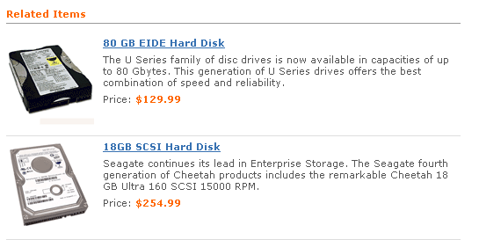

Related Product Options
If you selected the 'Option Based' pricing type, you must relate this product with at least one product option. For all other types you can relate this product to zero or more product options. Enter a single ID or a comma-separated list of multiple IDs for product options that are related to this product. There is a link called Related IDs that you simply click on to see all of the categories you can choose from.

Here you simply check the Product Option categories that you want to present on this product. If you sell computers and want to offer hard disk upgrades, you would select the heading where you offered several different hard disk options.

Visibility

Product Visibility/Product Visibility Selection
This field allows you to control which users can view this product. You can set this product up to be viewed by anyone (for all of your standard customers), only users belonging to the groups you specify using the Product Visibility Groups field (see the groups listed below), or to be hidden from everyone (perfect when you’re working on products for a future release that you aren’t quite ready for everyone to know about just yet)

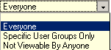

Product Visibility Groups
If you selected to allow only certain user groups to access this product under the Product Visibility Selection field, select the groups for which this product should be made visible.

- admin - Backend Administration
- affiliate – Access For Your Affiliates
- reports - Backend Reports (Administration)
- superuser - Backend Superuser (Your Web Designer, Corporate Officers)
- users - Basic Account (Your customers)
- wholesale - Wholesale Access for your dealers

Commerce
The Commerce section deals with everything you need in regards to orders placed on your store and setting up your store for commerce.

Checkout Form Fields
This field controls the various alternative checkout options that a customer may present. This will help you set up special forms for Gift Certificates, Discounts, Tax Exempt customers, etc.

This is an example of how this form looks on your checkout:

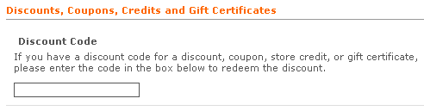

Display Name
The display name for the field used in XHTML output during checkout and in mail messages. See the example below:
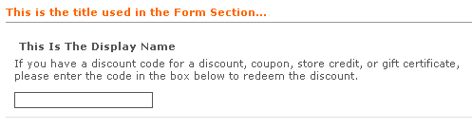
Form Section
The name of the section of the checkout form this field should be printed in. To create a new section, simply enter in a section that has not yet been used. See above for an example of where you text goes in the Form Section.

Display Description
This simply gives more detail to the customer to aid them in filling out this particular section of the form. It can be displayed for the form field in XHTML output. See example below:

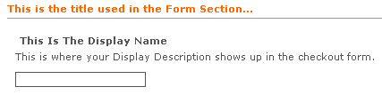
Important Note:

All Kryptronic products now contain a WYSIWYG (What You See Is What You Get) editor on fields that contain XHTML code. Why is this, you may ask? Now, text entries can be automatically converted to XHTML by simply typing them into this field and then clicking on the Bold/Italic/Underline and other text tools just like you do in a word processor. The software now just converts it for you so you don’t have to learn basic HTML programming. To launch the WYSIWYG editor just click on the blue WYSIWYG Editor: Load Editor link located in the various appropriate fields. It will launch the WYSIWYG toolbar that looks like this:

Required Indicator
Must your customer select something in this field in order to complete the order? If the answer is yes, set this indicator to “True”. If not, set this indicator to “False”

Display Indicator
Indicator used to determine whether this field is displayed on the checkout form. Set this field to “True” to display it and “False” to hide it.

Form Field Type
This is the XHTML form field type used to display the checkout field. Just like other option fields in the software, if you select a field type of Selection, Checkboxes or Radio Buttons, make sure you enter at least one item in the Selection Items field that follows.

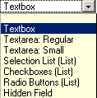

Field Order
This field allows you to place the checkout form elements of your shopping cart in the order you choose. Start with “0” and work on up. The fields are sorted in ascending order based on this numeric indicator.

Selection Items
If you’ve chosen a list of items to choose from during checkout, this is where you would display them. You have 20 different fields that you can enter data into that will be displayed in the format you’ve chosen above. In this case, the items are displayed in the Radio Buttons (List). See example below:

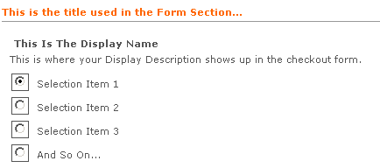

Custom Sale Methods

From here you can create custom sale methods that you can offer your customers. Some of the built in templates include: Buy X Items Save Y Amount, Buy X Items Save X Percent, Total Of X, Save Y Amount, Total Of X, Save Y Percent. These are just creative templates to help you encourage your customers to purchase more items on your store.

Identifier
This identifier is used within the software to specify this custom sale method. This is only for the backend identity of this method, so you can abbreviate it if you choose.

Display Name
This is the name for this custom sale method.

Sale Method PHP Content
Enter the content for this custom sale method below. This content should be written in standards compliant XHTML and should contain PHP code. The PHP code in this custom sale method should be based on the XHTML Includes used by this software.

Custom Surcharge Methods
Custom Surcharge Method/Identifier
This identifier is used within the software to specify this custom surcharge method.

Display Name
This is the name for this custom surcharge method.

Surcharge Method PHP Content
Enter the content for this custom surcharge method in the space provided. The PHP code in this custom surcharge method should be based on the includes used by this software.

Decrypt Offline Order Data

This form is used to decrypt information sent to you via email for offline orders. Typically credit card numbers, switch/solo card numbers and CVV2 data is sent in encrypted format for offline orders.

Encrypted Data
Enter the encrypted data in this field. This is given when an offline order is emailed to you. You then need to copy the data from this email into this field for it to be decrypted. Kryptronic now also has an Offline Decryptor available, just contact salesdesk@kryptronic.com for more information on purchasing.

Discount Codes

This field will allow you to manage any discounts you may offer your customers throughout the year. You can offer percentage-based pricing, flat discounts on all or selected products, or free shipping for all or selected products.

Discount Code Identifier
This is the background identity information that the software uses to identify this discount code. It is never displayed, so feel free to abbreviate it.

Discount Code Type
Select Expiring to disable this discount code when empty. Select a Non-expiring type to keep the code intact for multiple uses.

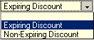

Discount Code Value
This is the discount code value. Enter a currency amount using the base currency for this application or enter a percentage amount. If you enter a percentage, be sure to include the percent sign (%) after your entry (example: 10.000%). If you enter a currency amount, do not include a currency symbol - enter only an amount (example: 10.00). To make this code good for free shipping, enter 'FREESHIPPING' for the value instead of a currency amount or percentage amount.

Active Status
Set this field to “True” if you are currently offering this discount. Set it to “False” if this discount is currently not being offered.

Discount Delivery Charges
This indicator when set to true makes this discount code applicable to delivery charges. When set to false, delivery charges are not discounted.

Product Limitations
Product Limitation Type
Select the product limitation type (if any) for this discount code. You can limit this code to only related products that you’ll select, to all products or to everything but the products you’ve excluded in the Related Products Field. This “Apply To All Except Related Products” entry can be handy if your discount applies to just about everything in your store but a few items.
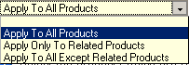
Related Products
Here, you can simply check the products that you want this discount to apply to.

Orders (Completed and Processing)
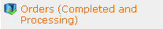

This is where you will access and work with your Completed and Processing orders. These orders have been paid for by the customer and are either completed or waiting for you to complete. You will have several choices upon entering this area.

Order/Order Number
This unique order number is used within the software to identify this order.

Order Date
This is the date and time on which the order was placed.

User Session ID
The user session id tied to this customer and this order.

Order Status
This is the status of this order. Orders marked as 'Pending Payment' have not been processed and should not be shipped. If the status for this order is changed to 'Completed', all shipped items associated with this order will be updated so their status is 'Shipped'.

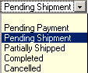

Payment Method
The payment method used to process this order.

Referring URL or Affiliate Code
This field holds either a referring URL or an affiliate code assigned to the customer. This information is transmitted to the software via the HTTP_REFERER environment variable or a 'mktsrc' (market source) parameter in a referring URL at the time the customer first visits the site.

Customer IP Address
The customer's IP address at the time of the order.

Guest Order Status
Indicates whether this order was placed by a user acting as a guest. Guest orders are not available for order review by account holders.

Totals/Order Total
This is the one-time total amount billed for the order.

Recurring Charge Total
This is the total recurring amount billed for the order.

Item Subtotal
This is the subtotal of all items contained in the order.

State/Province Tax Total
This is the state/province tax for the order.

Country Tax Total
This is the country tax for the order.

Country Tax Refund Total
This is the country tax refund for the order.

Custom Sale Total
This is the custom sale total for the order.

Custom Surcharge Total
This is the custom surcharge total for the order.

Discount Total
This is the discount total for the order.

Delivery Total
This is the delivery total for the order.

Affiliate Commission Total
This is the total commission amount payable to an affiliate for this order.

Checkout Fields/Discount Code
This is discount code (if any) used for the order.

Tax Exemption Number
This number, if entered by the customer, is their tax exemption number. This number may be a EU VAT or Canadian Provincial Sales Tax Vendor Permit number.

Tax Disability Status
If selected by the customer, indicates whether this customer has a disability and is subject to disability tax treatment.

Custom Sale Text
This is text associated with the custom sale (if any) for this order.

Custom Surcharge Text
This is text associated with the custom surcharge (if any) for this order.

Processor Token
The token used by the online processor. This token is used by a limited number of processors.

Contact Information
This set of fields displays all of the customer contact information. Just standard Name, Company, Phone, Fax and Email contact information is displayed here.

Billing Address
As the title says, this collection of fields contains all of the billing address information for this customer. It also flags a commercial or residential address.

Custom Fields
If you created any custom fields in your checkout process…that information would be displayed here.

Post Order Updates/Affiliate Commissions Updated
Indicates whether affiliate commissions have been calculated for this order. Commissions are updated automatically for orders processed via gateways that have post order updates enabled.

Inventory Levels Updated
Indicates whether inventory levels have been updated for this order. Inventory levels are updated automatically for orders processed via gateways that have post order updates enabled.

Discount Code Updated
Indicates whether the discount code (if used) has been updated for this order. Discount codes are updated automatically for orders processed via gateways that have post order updates enabled.

Exported to QuickBooks
Indicates whether the order has been exported to QuickBooks. This is automatically updated when a Quickbooks export is done. Only orders with a Completed status can be exported to QuickBooks.

Exported to Peachtree
Indicates whether the order has been exported to Peachtree. This is automatically updated when a Peachtree export is done. Only orders with a Completed status can be exported to Peachtree.

Exported To Sage
Indicates whether the order has been exported to Sage. This is automatically updated when a Sage export is done. Only orders with a Completed status can be exported to Sage.

Exported to T-Hub
Indicates whether the order has been exported to T-Hub. This is automatically updated when a T-Hub UpdateOrders request is received for an order.

Comments/Internal Comments
Comments to be viewed internally for this order. These comments are only available via this interface and are not made public.

External Comments
Comments to be viewed externally for this order. These comments will be viewable by the customer when reviewing their order.

Package Tracking/UPS Tracking Information
This field holds either a single UPS package tracking number or a comma delimited list of UPS package tracking numbers. Enter any UPS tracking number associated with this order to enable package tracking for users.

USPS Tracking Information
This field holds either a single USPS package tracking number or a comma delimited list of USPS package tracking numbers. Enter any USPS tracking number associated with this order to enable package tracking for users.

FedEx Tracking Information
This field holds either a single FedEx package tracking number or a comma delimited list of FedEx package tracking numbers. Enter any FedEx tracking number associated with this order to enable package tracking for users.

Delete
This simply deletes the order in question. It will give you a chance to cancel before proceeding.

Manage Items
This feature displays the order number and item detail. From here you can choose to view and in some cases, adjust the following fields:

Order Item/Order Number
This is the order number this item belongs to.

Order Date
This is the date and time on which the order was placed.

Delivery Status

For items that are shipped, this status defaults immediately after an order is placed to Pending Shipment. This status is automatically updated when an item is assigned to a shipping package. For items that are not shipped, this status is set to Not Applicable.

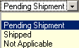

Delivery Method
The delivery method used to send this item.

Item Detail
This collection of fields contains all of the item detail information for the product that was ordered…Name, number, identifier, quantity ordered and optional items.

Totals
This field shows you either the one time sub total of a particular order, or the recurring total that was charged for the order.

Delivery Address
Displays the Ship To: details for the order in question. Also displays whether the ship to address is a Commercial or Residential Address.

Extension Module Information
This field will display any Extension Module info.

Summary/Invoice
This simply displays the invoice which the customer received.

Post Order Updates
Here, you can select the types of post-order updates you would like to run on the selected order. They can be associated with various XMODs you may have installed or as simple as resending your customer their confirmation message. Just check the updates you want and then click on the Submit button.

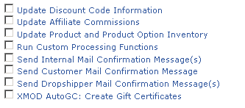

Important Note:
Most post-order update tasks require the order have a 'Completed' status. For orders that were processed using a gateway that supports post-order updates (most of them), these tasks were completed when the order was initially processed by the customer.

Orders (Pending and Cancelled)
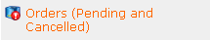

This is where you will access and work with your Pending and Cancelled orders. These orders have either not been paid for by the customer or have been cancelled. You will have several choices upon entering this area.

Order/Order Number
This unique order number is used within the software to identify this order.

Order Date
This is the date and time on which the order was placed.

User Session ID
The user session id tied to this customer and this order.

Order Status
This is the status of this order. Orders marked as 'Pending Payment' have not been processed and should not be shipped. If the status for this order is changed to 'Completed', all shipped items associated with this order will be updated so their status is 'Shipped'.

Payment Method
The payment method used to process this order.

Referring URL or Affiliate Code
This field holds either a referring URL or an affiliate code assigned to the customer. This information is transmitted to the software via the HTTP_REFERER environment variable or a 'mktsrc' (market source) parameter in a referring URL at the time the customer first visits the site.

Customer IP Address
The customer's IP address at the time of the order.

Guest Order Status
Indicates whether this order was placed by a user acting as a guest. Guest orders are not available for order review by account holders.

Totals/Order Total
This is the one-time total amount billed for the order.

Recurring Charge Total
This is the total recurring amount billed for the order.

Item Subtotal
This is the subtotal of all items contained in the order.

State/Province Tax Total
This is the state/province tax for the order.

Country Tax Total
This is the country tax for the order.

Custom Sale Total
This is the custom sale total for the order.

Discount Total
This is the discount total for the order.

Delivery Total
This is the delivery total for the order.

Affiliate Commission Total
This is the total commission amount payable to an affiliate for this order.

Checkout Fields/Discount Code
This is discount code (if any) used for the order.

Tax Exemption Number
This number, if entered by the customer, is their tax exemption number. This number may be a EU VAT or Canadian Provincial Sales Tax Vendor Permit number.

Custom Sale Text
This is text associated with the custom sale (if any) for this order.

Processor Token
The token used by the online processor. This token is used by a limited number of processors.

Contact Information
This set of fields displays all of the customer contact information. Just standard Name, Company, Phone, Fax and Email contact information is displayed here.

Billing Address
As the title says, this collection of fields contains all of the billing address information for this customer. It also flags a commercial or residential address.

Custom Fields
If you created any custom fields in your checkout process…that information would be displayed here.

Post Order Updates/Affiliate Commissions Updated
Indicates whether affiliate commissions have been calculated for this order. Commissions are updated automatically for orders processed via gateways that have post order updates enabled.

Inventory Levels Updated
Indicates whether inventory levels have been updated for this order. Inventory levels are updated automatically for orders processed via gateways that have post order updates enabled.

Discount Code Updated
Indicates whether the discount code (if used) has been updated for this order. Discount codes are updated automatically for orders processed via gateways that have post order updates enabled.

Exported to QuickBooks
Indicates whether the order has been exported to QuickBooks. This is automatically updated when a Quickbooks export is done. Only orders with a Completed status can be exported to QuickBooks.

Exported to Peachtree
Indicates whether the order has been exported to Peachtree. This is automatically updated when a Peachtree export is done. Only orders with a Completed status can be exported to Peachtree.

Exported To Sage
Indicates whether the order has been exported to Sage. This is automatically updated when a Sage export is done. Only orders with a Completed status can be exported to Sage.

Exported to T-Hub
Indicates whether the order has been exported to T-Hub. This is automatically updated when a T-Hub UpdateOrders request is received for an order.

Comments/Internal Comments
Comments to be viewed internally for this order. These comments are only available via this interface and are not made public.

External Comments
Comments to be viewed externally for this order. These comments will be viewable by the customer when reviewing their order.

Package Tracking/UPS Tracking Information
This field holds either a single UPS package tracking number or a comma delimited list of UPS package tracking numbers. Enter any UPS tracking number associated with this order to enable package tracking for users.

USPS Tracking Information
This field holds either a single USPS package tracking number or a comma delimited list of USPS package tracking numbers. Enter any USPS tracking number associated with this order to enable package tracking for users.

FedEx Tracking Information
This field holds either a single FedEx package tracking number or a comma delimited list of FedEx package tracking numbers. Enter any FedEx tracking number associated with this order to enable package tracking for users.

Delete
This simply deletes the order in question. It will give you a chance to cancel before proceeding.

Manage Items
This feature displays the order number and item detail. From here you can choose to view and in some cases, adjust the following fields:

Order Item/Order Number
This is the order number this item belongs to.

Order Date
This is the date and time on which the order was placed.

Delivery Status

For items that are shipped, this status defaults immediately after an order is placed to Pending Shipment. This status is automatically updated when an item is assigned to a shipping package. For items that are not shipped, this status is set to Not Applicable.

Delivery Method
The delivery method used to send this item.

Item Detail
This collection of fields contains all of the item detail information for the product that was ordered…Name, number, identifier, quantity ordered and optional items.

Totals
This field shows you either the one time sub total of a particular order, or the recurring total that was charged for the order.

Delivery Address
Displays the Ship To: details for the order in question. Also displays whether the ship to address is a Commercial or Residential Address.

Followup Information
This field will display whether a Followup message has been sent for this order.

Summary/Invoice
This simply displays the invoice which the customer received.

Post Order Updates
Here, you can select the types of post-order updates you would like to run on the selected order. They can be associated with various XMODs you may have installed or as simple as resending your customer their confirmation message. Just check the updates you want and then click on the Submit button.

Important Note:
Most post-order update tasks require the order have a 'Completed' status. For orders that were processed using a gateway that supports post-order updates (most of them), these tasks were completed when the order was initially processed by the customer.

Processing Gateways

This field controls the processing gateways that you use to process credit cards on your web site. You have many different options to choose from here. If you already have a web store set up, you probably already have a gateway that is likely supported here. If you are new to setting up your store, then you have many “canned” options that you can choose from and you can add as your store grows and more support is required.

Many small businesses do not carry stock of every single product that they advertise on their web stores. In this case, you probably don’t want your store to process the cards of your customers automatically. Perhaps you would prefer to process cards manually and only charge your customers at the time of shipment. ClickCartPro/EuropaCart offers you enough flexibility that you can configure it to match the exact methods that fit your working style.

If you have experience adding gateways and do not see your particular gateway support, simply click on the Add button and follow the following steps.

If you do see the various gateways you use all listed, simply scan to the end of this chapter and each individual gateway is addressed with specific instructions provided so that you can hook that gateway into your checkout system.

Much of this information is obtained when you sign up for a particular gateway.

Payment Gateway/Identifier
This unique gateway identifier is used to identify this gateway within the software. This identifier must be unique, but can be abbreviated, as your customers will not see it.

Gateway Name
This name is used within the software to reference this gateway. It is referred to by administrators on the backend and not displayed for the customers.

Active Status
This field shows the current status of this gateway. If you set it to “True”, this gateway will be made available for checkout processing.

Gateway URL Type
This is the type of URL used by this software. An internal URL uses this software and embedded online processing classes for processing. It is capable of approving a credit charge without any manual intervention. It simply means that the software contacts the payment processing gateway directly under the covers and requests authorization for the credit charge the customer entered then presents the results to the customer (approved or not) and does the appropriate post processing if applicable. An external URL uses an external URL with a relay and response transaction much like old style manual credit card machines that dialed up a secondary company to obtain an approval.

Field Display Text
This display text is used to present an option for this gateway to the customer during checkout. It better describes this method so your customers understand which choices they want to make.

Field Display Order
The field order numeric allows display of the gateways in the checkout form in a particular order. The fields are sorted in ascending order based on this numeric indicator. Start with “0” for the first option you want to present on up.

Perform Post-Order Updates
Indicate whether orders processed using this gateway should perform post-order updates automatically. Post-order updates include updating inventory and discount codes as well as affiliate commissions. Post-order updates should only be performed for gateways that process transactions in real time.

Supports Recurring Billing
Indicate whether this gateway supports recurring billing.

Fields/Response Field Name: Response Code

This field is marked Advanced because it should never need to be changed by the storeowner. Every processor integration uses a response code field to transmit a transaction authorization or failure code back to this software.

Response Field Name: Order Number
Every processor integration uses an order number field to transmit the transaction order number back to this software with a response code. Enter the order number field used by this gateway below. Again, this should never be changed by the store owner, as the information should always be correct.

Request Field Name: Order Total
For processor integrations that use internal URLs for processing, this field is used to ensure the order total has not been tampered with by the customer. The value of field you specify here is matched against the order total to verify the order total is accurate.

Security/Response Codes
Enter a single or comma delimited list of response codes issued by this gateway. All codes entered here should be valid codes that represent an accepted transaction. Do not include failed transaction response codes here. Again, this should never be changed by the store owner, as the information should always be correct.

Security/Referring URL String
The referring URL string contains text that must be contained in the referring URL for orders to be accepted using this gateway. Typically this string is set to an application script name or processor domain name.

Transaction Key/Password
Some gateways require the use of a transaction key, hash or password to process transactions. If this gateway requires such a key, hash or password, enter it here. Gateways that require a transaction key include: Authorize.net/Wells Fargo AIM and SIM, ECHOnline, EFSNET, NetBilling and FirstPay.

Gateway User/Store ID
For gateways that require the use of a user id or store number, enter that here. Any additional information to be entered for your account (example: Verisign Partner ID) is entered directly in the Form Display Code field in a few steps.

Form Display Code
The PHP code entered here is used to set up the XHTML form used to process an order for this gateway. The PHP code in this display should be based on the XHTML Includes used by this software. Any XHTML content included in this display should be written as standards compliant XHTML.

Supported Payment Methods and Instructions For Installation
The following customer payment methods are supported within the software. Just locate the methods that you prefer to use and follow the instructions for their use within your store.

PayPal Website Payments Pro Management

Configuring the PayPal Website Payments Pro payment method is quite easy. All of the controls are in the Orders and Payment menu. This is how you can quickly set up PayPal Website Payments Pro:

STEP 1: Getting Your Webserver Ready

- The PayPal Website Payments Pro payment methods require you to use a secure server for processing credit cards transparently using the 'PayPal (Pro Direct Method) - Secure Server' method. Make sure your host has set up a secure (SSL) webserver account for you. If you did not originally configure SSL URLs when you installed the program, access the installer to do so.

STEP 2: Getting Your PayPal Account Ready

- Login to your PayPal account at www.paypal.com.

- Click the 'Profile' tab, then select the 'API Access' link.

- Click the 'API Certificate Request' link, complete the form on the following page. Make note of the account name and password you select and then click 'Continue'. On the following page, review the information submitted, and if it's correct, click the 'Generate Certificate' link. On the next page, click the 'Download' link and save the file 'cert_key_pem.txt' to your computer.

- Click the 'Merchant Tools' tab and select the 'Virtual Terminal' link next to the PayPal Website Payments Pro section.

- Complete the Virtual Terminal application and wait approximately two days to receive your approval email.

- Once you receive your approval email, login to PayPal, select the 'Virtual Terminal' link again and choose to Accept the Monthly Billing Agreement.

STEP 3: Setting Up ClickCartPro/EuropaCart

- Access the management interface function | Settings: Application Settings Menu | PayPal Website Payments Pro Settings.

- Save your key file. Simply paste the contents of your key file into the Keyfile Contents field.

- Set 'Enable PayPal Website Payments Pro Express Checkout Link' to true.

- In the field 'API Login: User Name', enter in the account name you selected when setting up your certificate key file on PayPal's site.

- In the field 'API Login: User Password', enter in the password you selected when setting up your certificate key file on PayPal's site.

- None of the other fields on that page need to be modified.

- In the management interface, select Commerce/Manage Processing Gateways function.

- If you previously accepted payments using PayPal's Standard method, and the payment method 'PayPal (Standard Method) - Payment Form' is 'Active', choose to 'Update' that method and set it to 'Inactive'.

- Choose to 'Update' the 'PayPal (Pro Express Method) - Payment Form' payment method. Set that method to 'Active'. You only need to update that single field on this page.

- Choose to 'Update' the 'PayPal (Pro Direct Method) - Secure Server' payment method. Set that method to 'Active'. You only need to update that single field on this page.

- After you have completed these steps, your online store will be ready to accept payments via PayPal Website Payments Pro.

Recurring Billing

Please note: The PayPal Website Payments Pro API (Application Programming Interface) available from PayPal does not support recurring billing transactions. If you need to support recurring billing transactions in real time through your online store, and you would like to use PayPal, choose to use the 'PayPal (Standard Method) - Payment Form' payment method.

Online Processing Setup

Configuring available payment methods is quite simple. All of the controls are in the Commerce/Manage Processing Gateways function.

If you plan on using the recurring billing function of the software, please refer to the Recurring Billing section.

First, you have to decide which type of order process best suits your site. You can choose more than one of the following methods:

Contact Customer

No payments accepted online. The customer is notified that you will contact them via telephone to discuss payment options. Though this saves you any online processing and security issues, it also means that you have to manually call each customer to obtain the correct payment method. This is the default method used while you are setting up your store before other customer payment options are added.

Offline Processing (Credit Card & Switch/Solo Cards)

Collect credit card and/or Switch/Solo card information on your own secure server, encrypt the numbers and then email the primary order email address an encrypted decrypt key. Credit card numbers can then be decrypted using the Manage Online Orders function. This would be used for stores that want to run credit cards manually. This can be handy if you have products that you must order in or ship later than same day…it keeps customers happy when there card isn’t charged before the product is shipped.

Accept Checks or Purchase Orders

You can allow your users to pay by check or purchase order by presenting them with a printable/faxable version of their order that can be sent in to you for payment. This method can be particularly appealing to customers who fear identity theft via Internet credit card transactions.

Process Payments Through PayPal

You can accept payments with your PayPal account. If users don't have their own account, they will be prompted by PayPal to create one.

Process With A Payment Gateway

This is the application id that is being used in most cases it is ccp0 or gbu0 (British version)
Be sure to remove the {} when making the changes in the processor site and only use ccp0.

Collect credit card information on your own secure server and have an online processing partner validate and process the order or use an online processing partner's secure order form for credit card number entry. Both methods are supported and are easily configurable. If you have a large supply of products that are always in stock, this is the quickest method for processing payment and shipping orders.

Currently a large listing of payment processors are supported:

- Authorize.Net (SIM & AIM)
- Cardservice Linkpoint (HTML & API)
- Verisign (Payflow Link)
- iTransact
- WorldPay (WorldDirect)
- Planet Payment
- RTware
- 2CheckOut (Authnet)
- Wells Fargo (Secure Source & BOA)
- PaySystems
- ViaKlix
- GoRealtime.Com
- ECHOnline
- EFSNET
- InternetSecure
- PlugNPay
- SurePay
- SkipJack
- PSiGate
- Netbilling
- BluePay (API)
- FirstPay
- Protx
- Paypoint.net (SECpay)
- NoCHEX
- EPDQ
- HSBC

To configure this software package to work properly with your online processing partner's methods, every bit of information that is transmitted can be configured. In some cases, namely the interfaces that do not use a third party payment gateway, it is not necessary to make any modifications.

If you are using a third party payment gateway, you will need to enter your username / storename / storeid in the Gateway User/Store ID field. You will need to replace the string 'your_username' with the username your processor assigned to you.

Since all pieces of transmitted information are configurable and this package is an open source the opportunity is here to configure this package for processors other than those that are provided in the package. There is an insert function available in the management interface to allow you to configure a processor that is not currently supported. Just follow a similar processor's entry as an example if you choose to create a new one.

In addition, it is possible to post information from this program to another secure script, even an ASP script on an NT web server. The information collected there can be sent, for validation, off to your online processing partner's site before returning to your non-secure site for order fulfillment. The possibilities are endless. This program is capable, however, of running securely on it's own.

If your selection was to use a Secure Server method, edit the list of credit cards in the Form Display Code field. If you selected to use an online processing partner's payment form this information will be collected on their site.

Setting Up Specific Online Processors

Several online processors are listed below because their setup requires additional configuration using the admin functions on their site or require the entry of a key or password in addition to the username entry required by all. Review the instructions below.

If your processor is not listed below with specific instructions, no configuration on their site using their admin utility is necessary. The following processors do not require additional setup but do require that your password be entered in addition to your username. Passwords are entered in the 'Transaction Key/Password' field and are encrypted for your security.

- EFSNET
- FirstPay
- SurePay
- Paypoint.net (SECPay)
- NOChex

The remaining processors below require additional configuration using the processor's site admin utility.

Authorize.Net AIM & Wells Fargo (Authnet Interface)

- Login to your account at the processor's site and choose the Settings function.

- Under the Settings | Test Mode function, set the system to 'LIVE MODE'.

- Under the Settings | Transaction Version function, set the Transaction Version to '3.1'.

- Under the Settings | Password-Required Mode function, check the box next to 'Require Password for ALL Transactions'.

- Under the Settings | Obtain Transaction Key function, provide your 'Secret Answer' and check the box labeled 'Disable Old Transaction key'. After clicking the submit button, you will be presented with your Transaction Key, which you will need to copy.

- Under the Settings | Form Fields function, uncheck every checkbox, then check these two: Invoice # - Required and Customer ID - Required.

- Logout of your account at the processor's site and login to the management interface.

- For the Payment Method select the appropriate payment method.

- In the Update Payment Method function set the Active Status to Active.

- Now enter your id in the Gateway User/Store ID field. Replace the string 'your_username' with your processor login.

- In the 'Transaction Key/Password' field, enter the Transaction Key you created and copied while using the processor interface.

- Click 'Submit' and log out of the management interface. You are done.

Authorize.Net SIM

- Login to your account at the processor's site and choose the Settings function.

- Under the Settings | Test Mode function, set the system to 'LIVE MODE'.

- Under the Settings | Transaction Version function, set the Transaction Version to '3.1'.

- Under the Settings | Password-Required Mode function, check the box next to 'Require Password for ALL Transactions'.

- Under the Settings | Obtain Transaction Key function, provide your 'Secret Answer' and check the box labeled 'Disable Old Transaction key'. After clicking the submit button, you will be presented with your Transaction Key, which you will need to copy.

- Under the Settings | Form Fields function, uncheck every checkbox, then check these two: Invoice # - Required and Customer ID - Required.

- Logout of your account at the processor's site and login to the management interface.

- For the Payment Method select the appropriate payment method.

- In the Update Payment Method function set the Active Status to Active.

- Now enter your id in the Gateway User/Store ID field. Replace the string 'your_username' with your processor login.

- In the 'Transaction Key/Password' field, enter the Transaction Key you created and copied while using the processor interface.

- Click 'Submit' and log out of the management interface. You are done.

2CheckOut

- For the Payment Method select the appropriate payment method.

- In the Update Payment Method function set the Active Status to Active.

- Now enter your id in the Gateway User/Store ID field. Replace the string 'your_username' with your processor login.

- Logout of the management interface and open a browser session with your online processor. Login to your account and select the Shopping Cart | Cart Details function. Set the value for the field named "Return to a routine on your site after credit card processed" to "Yes". For the "Return URL" field, enter in the full path to your script. Example: http://www.yourdomain.com/core/relay/{APP}.php

- Log out of processor's admin utility. You are done.

WorldPay

- For the Payment Method select the appropriate payment method.

- In the Update Payment Method function set the Active Status to Active.

- Now enter your id in the Gateway User/Store ID field. Replace the string 'your_username' with your processor login.

- Logout of the management interface and open a browser session with your online processor. Login to your account and select the Settings function.

- In the Installations section, click the button under Configuration Options for the Installation ID you want to manage.

- On the Configuration Options page, enter the full http path to your script (Example: http://www.yourdomain.com/core/relay/{APP}.php) in the 'Merchant's Shop URL' and "Callback URL" fields. Then check the boxes next to "Callback enabled?" and "Use callback response?". Click the "Save Changes" button.

- Log out of processor's admin utility. You are done.

Cardservice Linkpoint (API Only)

- When you signed up for your API processing account at linkpoint, you were provided with a key file. The contents of this key file need to be copied into the Linkpoint API Keyfile Contents field in the Store/Component/Settings/Linkpoint API Settings function.

- No other configuration is necessary for this method (other than entering your id in the Gateway User/Store ID field by replacing the string 'your_username' with your processor login).

Cardservice Linkpoint HTML

- Using the administrator, click on Store/Commerce/Manage Processing Gateways function.

- For the Payment Method, select the appropriate payment method.

- In the Update Payment Method function, set the Active Status to Active.

- Now enter your id in the Gateway User/Store ID field. Replace the string 'your_username' with your processor login.

- Logout of the management interface and open a browser session with your online processor. Login to your account.

- Go to Customization then Payment Form Settings and make the following changes: Delete any text in the "Recipient's Top" and "Recipient's Bottom" textboxes. For the "Order Submission Form URL", enter in the full path to your script. Example: http://www.yourdomain.com/core/relay/{APP}.php For the "Thank You Page URL", enter in the same URL as above and check the boxes for "Check here if this url is a CGI script." and "Check if you wish to automatically display specified URL after the LinkPoint HTML receipt page." Make sure both are checked. For the "Sorry Page URL", enter in the same URL as above and check the boxes for "Check here if this url is a CGI script." and "Check if you wish to automatically display specified URL after the LinkPoint HTML receipt page.". Make sure both are checked. In the "Custom Fields" section, enter in under the column "Name" for #1: "usrnum" and for #2: "tracknum". There is no need to check the boxes for "Make Viewable" or enter anything in the field "Caption" for either of these "Name" entries. In the "Customer's Receipt" section, uncheck the box "Check here if you would like to receive a copy of each receipt". You don't want CardService sending anything to your customer as the software does it for you. Click "Submit" at the bottom of the page.

- Log out of processor's admin utility. You are done.

Wells Fargo (BoA Interface)

- Using the administrator, click on Store/Commerce/Manage Processing Gateways function.

- For the Payment Method, select the appropriate payment method.

- In the Update Payment Method function, set the Active Status to Active.

- Now enter your id in the Gateway User/Store ID field. Replace the string 'your_username' with your processor login.

- Logout of the management interface and open a browser session with your online processor. Login to your account.

- Using the processor's admin interface, turn off all notification by email, both to you and the customer.

- Change your confirmation pages to custom instead of the default page and make the address for both pages 'http://www.yourdomain.com/core/relay/{APP}.php' or whatever location you have the program located. Regardless, make this the address for *BOTH* your reject and accept confirmation pages in the custom confirmation pages.

- Log out of processor's admin utility. You are done.

Verisign Payflow Link

- Using the administrator, click on Store/Commerce/Manage Processing Gateways function.

- For the Payment Method, select the appropriate payment method.

- In the Update Payment Method function, set the Active Status to Active.

- Now enter your id in the Gateway User/Store ID field. Replace the string 'your_username' with your processor login.

- Logout of the management interface and open a browser session with your online processor. Login to your account. Select the Account Info function.

- Go to General - Edit Configuration and make the following changes: For Return URL Method, choose POST. For Return URL, enter the full http path to your script. Example: http://www.yourdomain.com/core/relay/{APP}.php For Required Fields, check the boxes for Name, Address, City, State, Zip, Country and Email.

- Go to Security Options and make the following changes: Add the full http path to your script as an "Accepted URL". Example: http://www.yourdomain.com/core/relay/{APP}.php

- Click the submit button at the bottom of the page to update your settings.

- Log out of processor's admin utility. You are done.

ECHOnline Credit Card

- There is no configuration needed using the ECHO management interface - just be sure to have your ECHO merchant id and password that were issued to you.

- Login to the management interface.

- For the Payment Method select the appropriate payment method.

- In the Update Payment Method function set the Active Status to Active.

- Now enter your id in the Gateway User/Store ID field. Replace the string 'your_username' with your processor login.

- In the 'Transaction Key/Password' field, enter the password you have been issued for your merchant id.

- Click 'Submit' and log out of the management interface. You are done.

Planet Payment & RTware

- Using the administrator click on Store/Commerce/Manage Processing Gateways function.

- For the Payment Method select the appropriate payment method.

- In the Update Payment Method function set the Active Status to Active.

- Now enter your id in the Gateway User/Store ID field. Replace the string 'your_username' with your processor login.

- Logout of the management interface and open a browser session with your online processor. Login to your account and select the Settings function.

- Select the General Connection Setup function, then Response String Version. Ensure that the response string version is set to 3.1.

- Under the General Connection Setup function, select the Referrer URLs function. Choose to add a URL and on the following page, enter the full http path to your script.

- Under the General Connection Setup function, select the Response/Reciept URLs function. Choose to add a URL and on the following page, enter the full http path to your script. You do not need to make this a default Recipient Link or Relay Response URL, but it's acceptable if you choose to do so.

- Under the Payment And Receipt Forms function, select the Receipt Method function. Select to use a POST receipt method. Enter the full http path to your script in the Recipient Link URLs field.

- Under the Payment And Receipt Forms function, select the Form Fields function. There uncheck every checkbox, then check these two: Invoice # - Required and Customer ID - Required.

- Under the Automated Direct Connect function, select the ADC Relay Response function. Enter the full http path to your script in the URL field.

- Under the Security function, uncheck the Require Password For All Transactions box.

- Under the Email Receipts function, uncheck the Email Transaction Receipt To Customer box.

- For the CVV2 Verification and Address Verification functions, select levels that you feel comfortable with.

- Log out of processor's admin utility. You are done.

SkipJack

- Login to your account at the processor's site and choose the 'Preferences' function.

- Select the 'Response Files' function.

- Click the 'Send Customer to the following WebPages/URLs' radio button and in the four text boxes provided under that button, enter in the full path to your script. Example: http://www.yourdomain.com/core/relay/{APP}.php. The same entry goes in all four text boxes.

- Logout of your account at the processor's site. You are done.

PSiGate

- Enter your id in the Gateway User/Store ID field. Replace the string 'your_username' with your processor login.

- The default PSiGate response method is a GET response. If you have changed this to a POST response at PSiGate, change back to GET.

- PSiGate regulations specify that you must inform them whether you will be using their payment form or your own secure server to collect credit card information. Inform them of the method you're using and PSiGate will configure your account correctly.

NetBilling

- Under the Fraud Controls function, choose the Fraud Defense sub-function. Under the Enable Fraud Defense heading, make sure that Fraud Defense is Enabled. Under the Order integrity heading, make sure 'Enforce order integrity' is checked. Copy the Order integrity key as you will need it later. Make any other changes to these settings you wish. Click the Apply button.

- Under the Security function, choose the Access Security sub-function and for Payment Form Interfaces, make sure that 'Enable Payment Form V2.x (Universal) interface' is checked. Click the Apply button.

- Under the Setup function, choose the Website tools sub-function and click 'Browse Sites'. Choose to add a new site at the bottom of the list. Enter a Site Tag, Site Name and URL. Make note of the Site Name you choose. The URL used here is for reference only, so you can enter your main site URL here (not the full http path to {APP}.php).

- On the same page, next to the site you've added, click the 'Config' link. On the following page, enter your name, phone and email address in the Website Information section. Then, in the Default payment form settings section, enter the full path to your script for the Return URL and GiveUp URL fields. Example: http://www.yourdomain.com/core/relay/{APP}.php. Also, set the Return Method to POST and the Postback CGI URL to blank. For the Payment options field, make sure 'Accept Credit Card payments for this site' is checked and the Payment Form field is set to the default for your Site Name. Click the Apply button.

- Return to the Setup function, then choose the Website tools sub-function and click 'Browse Sites'. Next to the site you added previously, click the 'Email' link. On the following page, in the Email templates sent to merchant section, enter your email address in the 'To' field, and select the any email templates for your site you wish to use for the Standard receipt and Decline notice emails (if you don't want to use the default templates). Click the Apply button.

- Logout of your account at the processor's site and login to the management interface.

- For the Payment Method select the appropriate payment method.

- In the Update Payment Method function set the Active Status to Active.

- In the Processor Username field, replace the string 'your_accountnum:your_sitename' with your account number, followed by a colon (:) followed by the Site Name you created using the NetBilling administrator.

- In the 'Transaction Key/Password' field, enter the Crypto Hash you copied while using the processor interface.

- Click 'Submit' and log out of the management interface. You are done.

CyberSource

- Login to your Cybersource account and select the Settings menu option.

- Access the Account Information function in the Settings menu.

- In the 'Process Payment Transactions' section, select 'Hosted Order Page (HOP)' from the drop-down menu.

- In the 'Duplicate Order Check' section, select 'Decline duplicate orders' by checking the box next to that option.

- In the 'Shopping Cart' section, select 'ClickCartPro/EuropaCart' from the drop-down menu. If 'ClickCartPro/EuropaCart' is not listed, select 'Other' then enter 'ClickCartPro/EuropaCart' in the text box below the drop-down menu.

- Click the 'Update' button at the bottom of the page.

- Access the Hosted Order Page Settings function in the Settings menu.

- In the 'Simple Order POST' section, select 'Do not show the Hosted Order Page to my customers' by checking the box next to that option.

- In the 'Payment Details' section, de-select 'Display Tax Amount' by un-checking the box next to that option.

- In the 'Payment Types | Credit Cards' section, select all credit cards you wish to accept by checking the box next to each card name. In addition, check the 'Display' box for each CVV/CID/CVN option and un-check the 'Require' box for each CVV/CID/CVN option.

- In the 'Billing Information' section, check the 'Display' box and un-check the 'Edit' box for the Billing Fields.

- In the 'Shipping Information' section, check the 'Display' box and un-check the 'Edit' box for the Shipping Fields.

- In the 'Appearance | General' section, enter your company name in the 'Company Display Name' field and select the color scheme you wish to use by choosing it from the 'Color Scheme' drop-down menu.

- In the 'Appearance | Order Page' section, enter any HTML you wish to use for the 'Header' and 'Footer'. Leave the 'Background Image URL' field blank.

- In the 'Appearance | Receipt Page' section, enter the full http path to your script (Example: http://www.yourdomain.com/core/relay/{APP}.php) for the 'Receipt Response URL' field.

- In the 'Appearance | Decline Page' section, enter the full http path to your script (Example: http://www.yourdomain.com/core/relay/{APP}.php) for the 'Decline Response URL' field.

- In the 'Email | Addresses and Options' section, check the box next to the 'Send Merchant Receipt Email' field and enter your email address in the merchant's 'To Address' field. Un-check the box next to 'Send Customer Receipt Email'. For the customer email section, you can leave the 'From Address' and 'From Name' fields blank.

- In the 'Email | Appearance' section, you can leave the 'Header' and 'Footer' fields blank.

- Click the 'Update' button at the bottom of the page.

- Access the Security Keys function in the Settings menu.

- In the 'Generate HOP Script' section, select the PHP option, and save that script to your computer's hard disk drive. Make a note of the location of that script. It's named 'HOP.php'.

- Access the Smart Authorization function in the Settings menu.

- In the 'Smart Authorization' function, there are quite a few options for fraud settings. Set those authorization fields to whatever level you feel most comfortable with.

- Click the 'Update' button at the bottom of the page.

- Log out of processor's admin utility and login to the management interface.

- For the Payment Method select the appropriate payment method.

- In the Update Payment Method function set the Active Status to Active.

- In the Form Display Code section, follow the instructions regarding storing the HOP.php file you created on your server.

Recurring Billing

This software supports recurring billing transactions. For all payment methods that support recurring billing, the order process is exactly the same for customers.

Manual recurring billing requires that the store owner process the recurring transactions manually either by charging payment cards or sending invoices to customers on a recurring basis. The following payment methods support manual recurring billing:

- Contact Customer
- Offline (Credit Card)
- Offline (Switch/Solo)
- Check Payment
- Purchase Order

Fully automatic recurring billing requires no action by the storeowner to process recurring transactions. As part of the order process, the recurring transactions are set up with the processor and automatically set to occur. The following payment methods support fully automatic recurring billing:

- Cardservice Linkpoint API - Secure Server
- PayPal (Standard Method) - Payment Form

Semi automatic recurring billing requires initial action by the store owner to process recurring transactions. As part of the order process, the recurring transactions are set up with the processor, but need to be activated by the store owner. The following payment methods support semi automatic recurring billing:

- Authorize.Net AIM Credit Card - Secure Server
- Wells Fargo (Authnet) Credit Card - Secure Server

For these semi automatic recurring billing payment methods, follow the instructions below to activate the recurring billing:

- Login to your account at the processor's site and choose the Settings function.

- Once transactions have settled, access the 'Search and Download' function and search for the transaction you would like to make recurring. All transactions initiated by the software that should be made recurring have an order number ending with an 'R'.

- When you choose to view the Transaction Detail page for the order, you will see a link named 'Create ARB Subscription from Transaction'. Click this link and complete the 'Create New ARB Subscription' form to set the transaction up as recurring.

- Please note: As part of the order process, the first month's payment is made to set the order up on the Authorize.net system. You will need to start date to one month in the future to avoid double billing for the first month.

ProTX/Sagepay Form
- In admin under Commerce/Manage Processing Gateways click on Update next to the Gateway Name Sagepay (Protx) - Payment Form
- Change the Active Status to True
- Change the Gateway User/Store ID to your Protx Vendor name
- Change the Transaction Key/Password to you Protx encrypted password
- Click the submit button

Additional details on this gateway are provided on the Kryptronic Web Site Wiki at http://wiki.kryptronic.com/AddProtxFormUK

HSBC Payment Form
- In admin under Commerce/Manage Processing Gateways select Update next to the HSBC - Payment Form
- Change Active Status to True.
- Change Gateway User/Store ID to your HSBC store ID
- Change Transaction Key/Password to your HSBC Order Hash Key (Provided by HSBC by Fax or Letter).
- Active Status = True
- Click Submit.
This enables the HSBC gateway in test mode. When you are ready to go live you will need to change the following in the Form Display Code.
From:
$tmp[3] = 'T';
$olpform['fields']['HIDDEN'][] = array('name' => 'Mode',
'value' => $tmp[3]);
To:
$tmp[3] = 'P';
$olpform['fields']['HIDDEN'][] = array('name' => 'Mode',
'value' => $tmp[3]);

ePDQ Payment Form
First, you’ll need to password protect the {public_directory}/epdqrelay
In ClickCartPro/EuropaCart:

- In the admin go to Commerce/Manage Processing Gateways and Update - ePDQ - Payment Form
- Change Active Status to True.
- Change Gateway User/Store ID to your epdq client ID
- Change Transaction Key/Password to your epdq pass phrase.
- Click Submit.
In ePDQ:

- Click this link then fill in the following: https://cpiadmin.epdq.co.uk/cgi-bin/CcxBarclaysEpdqAdminTool.exe
- Passphrase, information type into Transaction Key / Password.
- Allowed URL, the normal location of the shopping script eg {public URL}/index.php
- Post Order Results, Yes
- Post URL, the location of the epdq script eg {public URL}/epdqrelay/ and post username and password, the username and password for the epdqrelay directory.

Exports

For your convenience, this software is equipped to export your customers, orders and items directly into your accounting system in order to save time and duplicate entry.

Peachtree Accounting Export

Use this interface to export your completed orders into Peachtree compatible CSV files. Before running this data export, ensure that you have updated the account names you use in Peachtree using the Peachtree Export Settings function under the Application Settings Menu for this application. This function will only export orders with a 'Completed' status that have not been previously exported. If you choose to export data to a file that already exists, that file will be deleted prior to creating a new export file.

Customers File
Enter the name of the file you would like created for the customers export below.

Items File
Enter the name of the file you would like created for the items export below.

Orders File
Enter the name of the file you would like created for the orders export below.

Quickbooks Accounting

Use this interface to export your completed orders into a Quickbooks compatible IIF file. Before running this data export, ensure that you have updated the account names you use in Quickbooks using the Quickbooks Export Settings function under the Application Settings Menu for this application. This function will only export orders with a 'Completed' status that have not been previously exported. If you choose to export data to a file that already exists, that file will be deleted prior to creating a new export file.

Export File Name
Enter the name of the file you would like created in this field.

Sage Accounting

Use this area to export your completed orders into a Sage compatible CSV files. Before running this data export, ensure that you have updated the account names you use in Sage using the Sage Export Settings function. This function will only export orders with a 'Completed' status that have not been previously exported. If you choose to export data to a file that already exists, that file will be deleted prior to creating a new export file.

Export File Name/Customers File
Enter the name of the file you would like created for the customers into this field.

Export File Name/Orders File
Enter the name of the file you would like created for the orders export into this field.

Modules

If you have purchased any of our popular XMOD expansion modules, this is where you will access and tweak those which have controls. XMODs are usually parceled out to the area of the software where they are most associated.

Shipping

This menu helps you set up all of the details for your shipping alternatives.

Custom Shipping Methods

Perhaps you want to offer shipping charges based on total item cost, quantity, weight or a percentage of the item cost? Perhaps you have your own custom shipping method. This is where you would configure and augment the various custom shipping methods. These items can all be updated, but only if you understand PHP programming. When you click on Update, you see the following self-explanatory information:

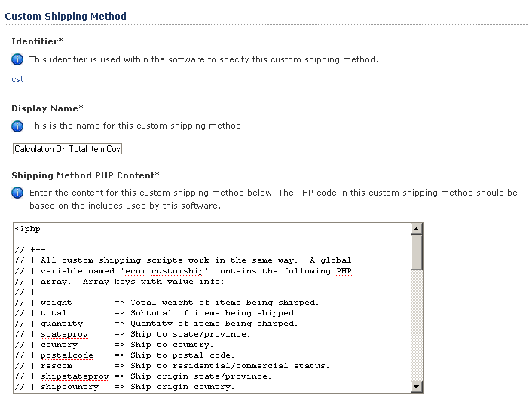

FedEx DirectConnect

Setting up your FedEx DirectConnect connection is a multi-step process. Follow these instructions to ensure your connection is set up properly.

- If you do not have a FedEx account number, visit http://www.fedex.com/ to set up a FedEx account online and obtain a FedEx account number.
- Using the same information you provided while setting up your FedEx account, complete the information below and click the 'Submit' button to retrieve a meter number from FedEx, which will automatically activate your connection.

Contact Information
The online form contains basic contact information that you’ll need to fill out in order to begin using FedEx DirectConnect.

Configure Intershipper Connection

Setting up your InterShipper connection is a multi-step process. Follow the instructions below to ensure your connection is set up properly.
- Visit the InterShipper web site at http://www.intershipper.com/ and click the login link that's presented.
- Complete the information required to register.
- After submitting the form you will receive a username and password. Save the username and password. Enter it in the provided spaces and press the “Submit” Button to activate your connection.
- After activating your connection, access the Intershipper Settings function to turn on/off shipping rates for various shippers.

Realtime Carriers

Identifier
This identifier is used within the software to specify this realtime shipping carrier.

Display Name
This is the realtime shipping carrier display name. It is used in displays to identify the carrier.

Rate Display Text
This text is used in displays where rate information is returned.

Tracking Display Text
This text is used in displays where tracking information is returned.

Connection Active Status
This indicates whether or not the connection is active for this realtime shipping carrier. If the connection is not active and you would like to activate it, choose to configure a connection for the carrier.

Carrier Supplies Rates
This indicates whether or not the carrier supplies realtime shipping rates via their connection.

Carrier Supplies Tracking
This indicates whether or not the carrier supplies realtime shipment tracking via their connection.

Connection URLs/Connection Rate URL
This URL is used for rate inquiries.

Connection Tracking URL
This URL is used for tracking inquiries.

Trademarks/Trademark Image
This image is used for both rate and tracking displays. The file shown in this field is currently associated with this item. If you wish to use a different file, either enter a new file name, or use the file upload to select the file you wish to use and have it upload automatically when you click on the Submit button.

Trademark Notice
This text is used to provide a trademark notice in rate and tracking displays. Do not include XHTML tags in this text.

Disclaimers/Tracking Disclaimers
The text in this box is used to provide a disclaimer in tracking displays. Do not include XHTML tags in this text.

Handling Disclaimer
The text in this box is used to provide a handling disclaimer in rate displays. Do not include XHTML tags in this text.

Notices/Weight Error Notice
The text in this box is used to provide a notice when weight errors occur during rate inquiries. Do not include XHTML tags in this text.

Dimensional Error Notice
The text in this box is used to provide a notice when dimensional errors occur during rate inquiries. Do not include XHTML tags in this text.

Realtime Services

This is where you manage the various services offered by your shipping partners. By this, we mean, Ground, 2nd Day, Overnight, etc. Here you can pick and choose which individual services offered by your shipper that you want to provide to you customers.

The services are basically set up for you, you simply scroll to the bottom of the individual pages to determine if that service will be available to your customers by choosing True for yes and False for no.

UPS Online Tools Connection

Setting up your UPS OnLine® Tools connection is a multi-step process. Follow the instructions to ensure your connection is set up properly. This interface will provide a connection to UPS for registration for UPS OnLine® Tools. Completion of the steps provided by this interface will ensure correct registration and activation.
- Select your country from the listing below and click the 'Submit' button to continue. UPS OnLine® Tools are only available in certain countries. A listing of available countries is available at: http://www.ec.ups.com/ecommerce/solutions/global_redirect.html
- You will then be presented with a license agreement, which you must accept to continue. Your registration information will also be collected and sent to UPS for validation.
- If your information is validated by UPS, your registration will be complete and your UPS OnLine® Tools connection will be activated.
- After the selection of your country from the list of available countries below, you will be presented with a form to complete in order to configure your UPS OnLine® Tools connection.

USPS WebTools

Setting up your USPS WebTools connection is a multi-step process. Follow the instructions below to ensure your connection is set up properly.

- Visit the USPS web site at http://www.uspswebtools.com/ and click the registration link that's presented.

- Complete all of the information requested on the registration page, be sure to agree to the USPS WebTools terms and conditions and submit the form.

- After submitting the form you will receive a username along with a development URL via email. Save the username and disregard the development URL.

- Between 7:00 AM and 11:00 PM Eastern time, call the USPS Internet Customer Care Center and speak to a representative. Provide the representative with your username, inform them that you have completed testing your integration, and are ready to have access to the production server. The representative will send you an email with the production server URL.

- Once you receive the production server URL via email from USPS, your account is production-ready. Enter in your username in the field provided and click the 'Submit' button to activate your connection.

Store Displays

This area of the product controls the look and feel of your site. It determines how you display and promote your products, categories, etc.

Category Displays

This category requires an understanding of PHP and HTML coding. If you do not have this skill set at your disposal, you may have to contract an outside source to make changes or additions to the contents of this menu. You can also contact salesdesk@kryptronic.com to receive a quote for designing a web site that reflects your business attitude.

Identifier and Name/Identifier
This identifier is used within the software to specify this display.

Display Name
This is the name for this display.

Display Content
Enter the content for this display below. This content should be written in standards compliant XHTML and should contain PHP code. The PHP code in this display should be based on the XHTML Includes used by this software.

Product Detail Displays

This category requires an understanding of PHP and HTML coding. If you do not have this skill set at your disposal, you may have to contract an outside source to make changes or additions to the contents of this menu. You can also contact salesdesk@kryptronic.com to receive a quote for designing a web site that reflects your business attitude.

Identifier and Name/Identifier
This identifier is used within the software to specify this display.

Display Name
This is the name for this display.

Display Content
Enter the content for this display below. This content should be written in standards compliant XHTML and should contain PHP code. The PHP code in this display should be based on the XHTML Includes used by this software.

Product List Displays

This category requires an understanding of PHP and HTML coding. If you do not have this skill set at your disposal, you may have to contract an outside source to make changes or additions to the contents of this menu. You can also contact salesdesk@kryptronic.com to receive a quote for designing a web site that reflects your business attitude.

Identifier and Name/Identifier
This identifier is used within the software to specify this display.

Display Name
This is the name for this display.

Display Content
Enter the content for this display below. This content should be written in standards compliant XHTML and should contain PHP code. The PHP code in this display should be based on the XHTML Includes used by this software.

Store Menu

Menu Item Identifier and Name/Menu ID
This is the unique identifier for this menu.

Display Name
Display name for this menu item used in the menu.

Display Order
The menu display order numeric allows display of menu items in the custom menu in a particular order. The menu items are sorted in ascending order based on this numeric indicator.

Menu Display Status
This indicator controls whether this menu item is displayed in the custom menu. Select True to display the menu or False not to display it.

Kryptronic Software End User License Agreement (EULA)

END USER LICENSE AGREEMENT FOR THE KRYPTRONIC HYBRID X CORE (CORE) AND CORE-BASED KRYPTRONIC SOFTWARE PRODUCTS

KRYPTRONIC, INC. LICENSES THE KRYPTRONIC HYBRID X CORE SOFTWARE PRODUCT AND OTHER CORE-BASED KRYPTRONIC SOFTWARE PRODUCTS TO YOU SUBJECT TO THE TERMS CONTAINED IN THIS END USER LICENSE AGREEMENT ("EULA"). READ THE TERMS OF THIS EULA CAREFULLY. BY INSTALLING, COPYING OR OTHERWISE USING THE SOFTWARE (AS DEFINED BELOW), YOU AGREE TO BE BOUND BY THE TERMS OF THIS EULA. IF YOU DO NOT AGREE TO THE TERMS OF THIS EULA, DO NOT INSTALL, COPY OR USE THE SOFTWARE.
NOTICE TO CUSTOMER
If you do not agree to the terms of this EULA, do not install, activate, or use this software. This EULA is a contract between you (either an individual or an entity) and Kryptronic, Inc. ("Kryptronic"), which governs your use of this Kryptronic software product that accompanies this EULA and related software components, which may include associated media, printed materials, and online or electronic documentation.
DEFINITIONS
This Kryptronic Hybrix X Core software package includes the Kryptronic Hybrid X Core ("CORE") software product, related CORE-Based Kryptronic software products designed for use with the CORE ("CORE-Based Software") and Open Source Software components. The KRYPTRONIC software product is composed of a proprietary KRYPTRONIC software and management interface component and other CORE-Based Software. KRYPTRONIC and CORE-Based Software are referred to collectively herin as ("Software"). This software package may include sample programs or scripts ("Sample Programs"). You may use and distribute Sample Programs under the terms set forth in the applicable Sample Programs files. In this EULA, the CORE, CORE-Based Software products, associated media, printed materials, and online or electronic documentation are collectively referred to as the "Software."
"Open Source Software" means various open source software components, including, without limitation, PEAR and the following PEAR packages: Auth_SASL, Archive_Tar, Console_Getopt, File_Find, Mail, Mail_mime, Net_SMTP and Net_Socket, licensed under the terms of applicable open source license agreements included in the materials relating to such software.
An "Installation" means a single physical installation of the Software.
A software license key ("Software License Key") issued to you by Kryptronic is required to use the Software.
WARNING FOR EVALUATION LICENSEES
The Software can be activated with a no-cost evaluation Software License Key. Evaluation Software License Keys have an expiration date ("Expiration Date"). If you activate the Software with an evaluation Software License Key: (i) you may use the Software until the Expiration Date only to evaluate the suitability of the Software for licensing on a for-fee basis; and (ii) THE SOFTWARE IS PROVIDED TO YOU "AS IS" WITHOUT WARRANTY OF ANY KIND, WHETHER EXPRESS, IMPLIED, STATUTORY, OR OTHERWISE. KRYPTRONIC BEARS NO LIABILITY FOR ANY DAMAGES RESULTING FROM USE (OR ATTEMPTED USE) OF THE SOFTWARE THROUGH AND AFTER THE EXPIRATION DATE, AND HAS NO DUTY TO PROVIDE SUPPORT TO YOU.
OPEN SOURCE SOFTWARE
The Open Source Software is composed of individual software components, each of which has its own copyright and its own applicable license conditions. You must review the licenses within the individual packages to understand your rights under them. The licenses can be found online at pear.php.net. Copyrights to the Open Source Software are held by the copyright holders indicated in the copyright notices found online at pear.php.net.
LICENSE
The Software is licensed, not sold. Subject to the terms and limitations of this EULA, Kryptronic hereby grants you a nonexclusive, nontransferable license, without rights to sublicense, to (i) Use the Software License Key to activate the Software to the extent permitted by your payment of applicable license fees (whether such fees are based on a single installation licensing model or any other Kryptronic approved licensing model); (ii) Install or have installed a single instance of the Software for each license fee paid; (iii) Use the Software in accordance with this EULA; (iV) Use the Software in a legal manner; and (V) Use the documentation accompanying the Software in connection with permitted uses of the Software.
LICENSE LIMITATIONS
You may not copy the Software except for a reasonable number of machine-readable copies of the Software for backup or archival purposes and except as expressly permitted in the License section above. You may not remove any titles, trademarks or trade names, copyright notices, legends, or other proprietary markings on the Software. You are not granted any rights to any trademarks or service marks of Kryptronic. Kryptronic retains all rights not expressly granted to you.
LICENSES REQUIRED FOR THIRD-PARTY SOFTWARE
The Software enables you to install third-party modules and extensions that further enhance it's functionality. You are responsible for obtaining any licenses necessary to operate any such third-party software, and must accept any EULAs required to use the software.
KRYPTRONIC'S RIGHT OF ENTRY
You hereby authorize Kryptronic to access your web server in order to inspect the Software in any reasonable manner verify your compliance with the terms hereof.
PROPRIETARY RIGHTS RESERVED BY KRYPTRONIC
Kryptronic retains all right, title, and interest in and to the Software and the Software License Key and in all related copyrights, trade secrets, patents, trademarks, and any other intellectual and industrial property and proprietary rights, including registrations, applications, renewals, and extensions of such rights.
RESTRICTIONS
You may not (i) Sell, lease, license, sublicense, distribute or otherwise transfer in whole or in part the Software or the Software License Key; (ii) Provide, disclose, divulge or make available to, or permit use of the Software in whole or in part by, any third party without Kryptronic's prior written consent; or (iii) Modify or create derivative works based upon the Software without Kryptronic's prior written consent. Except to the extent expressly permitted by applicable law, and to the extent that Kryptronic is not permitted by that applicable law to exclude or limit the following rights, you may not decompile, disassemble, reverse engineer, or otherwise attempt to derive source code from the Software, in whole or in part. You may not disclose the results of any benchmark test of the Software to any third party without Kryptronic's prior written approval.
SUPPORT AND SUBSCRIPTION SERVICES NOT INCLUDED
Kryptronic will not provide any support services under this EULA. This EULA does not give you any rights to any updates or upgrades to the Software or to any extensions or enhancements to the Software developed by Kryptronic at any time in the future. You may purchase support and subscription services separately. If you have purchased Kryptronic support and subscription services with the Software, these services are provided to you under the Support Contract Terms and Conditions posted on Kryptronic's Web site, and by accepting the terms of this EULA you are accepting these Support Contract Terms and Conditions. Any supplemental software code or related materials that Kryptronic provides to you as part of any support and subscription services are to be considered part of the Software and are subject to the terms and conditions of this EULA. Kryptronic may use any technical information you provide to Kryptronic for any Kryptronic business purposes without restriction, including for product support and development. Kryptronic will not use information in a form that personally identifies you.
TERMINATION
Kryptronic may terminate this EULA if you fail to comply with any term of this EULA. In the event of termination, you must destroy all copies of the Software and Software License Key. In addition you must remove all copies of the Software from all computers and terminals on which it is installed.
GOVERNMENT RESTRICTIONS
You may not export or re-export the Software except in compliance with the United States Export Administration Act and the related rules and regulations and similar non-U.S. government restrictions, if applicable. The Software and accompanying documentation are deemed to be "commercial computer software" and "commercial computer software documentation," respectively, pursuant to DFAR Section 227.7202 and FAR Section 12.212(b), as applicable. Any use, modification, reproduction, release, performing, displaying, or disclosing of the Software by the U.S. Government shall be governed solely by the terms of this EULA.
LIMITED WARRANTY
Kryptronic warrants, for your benefit alone, that the Software conforms in all material respects to the specifications for the current version of the Software. This warranty is expressly conditioned on your observance of the operating, security, and data-control procedures set forth in the Software Documentation.
EXCEPT FOR THE PRECEDING EXPRESS LIMITED WARRANTY, TO THE MAXIMUM EXTENT PERMITTED BY APPLICABLE LAW, KRYPTRONIC PROVIDES THE SOFTWARE WITHOUT ANY WARRANTIES OF ANY KIND, EXPRESS, IMPLIED, STATUTORY, OR IN ANY OTHER PROVISION OF THIS EULA OR COMMUNICATION WITH YOU, AND KRYPTRONIC SPECIFICALLY DISCLAIMS ANY IMPLIED WARRANTIES OF MERCHANTABILITY, FITNESS FOR A PARTICULAR PURPOSE, AND NON-INFRINGEMENT.
LIMITATION OF LIABILITY
TO THE MAXIMUM EXTENT PERMITTED BY APPLICABLE LAW, IN NO EVENT WILL KRYPTRONIC BE LIABLE FOR ANY LOST PROFITS OR BUSINESS OPPORTUNITIES, LOSS OF USE, BUSINESS INTERRUPTION, LOSS OF DATA, OR ANY OTHER INDIRECT, SPECIAL, INCIDENTAL, OR CONSEQUENTIAL DAMAGES UNDER ANY THEORY OF LIABILITY, WHETHER BASED IN CONTRACT, TORT, NEGLIGENCE, PRODUCT LIABILITY, OR OTHERWISE. BECAUSE SOME JURISDICTIONS DO NOT ALLOW THE EXCLUSION OR LIMITATION OF LIABILITY FOR CONSEQUENTIAL OR INCIDENTAL DAMAGES, THE PRECEDING LIMITATION MAY NOT APPLY TO YOU.
KRYPTRONIC'S LIABILITY UNDER THIS EULA WILL NOT, IN ANY EVENT, EXCEED THE LICENSE FEES, IF ANY, PAID BY YOU TO KRYPTRONIC FOR THE SOFTWARE LICENSED BY YOU UNDER THIS EULA.
THE FOREGOING LIMITATIONS SHALL APPLY TO THE MAXIMUM EXTENT PERMITTED BY APPLICABLE LAW, REGARDLESS OF WHETHER KRYPTRONIC HAS BEEN ADVISED OF THE POSSIBILITY OF SUCH DAMAGES AND REGARDLESS OF WHETHER ANY REMEDY FAILS OF ITS ESSENTIAL PURPOSE.
INJUNCTIVE RELIEF
You acknowledge that, in the event of your breach of any of the foregoing provisions, Kryptronic will not have an adequate remedy in money or damages. Kryptronic shall therefore be entitled to obtain an injunction against such breach from any court of competent jurisdiction immediately upon request. Kryptronic's right to obtain injunctive relief shall not limit its right to seek further remedies.
GENERAL
This EULA is governed by the laws of the State of Pennsylvania and the United States of America, without regard to conflict of law principles. The United Nations Convention for the International Sale of Goods shall not apply. This EULA is the entire agreement between us and supersedes the terms of any purchase orders and any other communications or advertising with respect to the Software. If any provision of this EULA is held invalid, the remainder of this EULA shall continue in full force and effect. This EULA may be modified only by written agreement signed by authorized representatives of you and Kryptronic.
CONTACT INFORMATION
If you have any questions about this EULA, or if you want to contact Kryptronic for any reason, please direct all correspondence to: Kryptronic, Inc., P.O. Box 865, York, PA 17403, United States of America or email salesdesk@kryptronic.com.
Kryptronic, the Kryptronic logo and all Kryptronic software names and logos are trademarks of Kryptronic, Inc. in the United States and/or various jurisdictions.

Program Credits

Codebase Development

Nick Hendler (Kryptronic, Inc.) has been the chief software developer for ClickCartPro/EuropaCart since it's initial version 1.0, which was developed in June 1999. Since then, the program has undergone extensive changes, which have resulted in the current version available today.
The codebase, which includes the library, modules and data architecture, are developed by solely by Kryptronic, Inc. and is distributed under license. ClickCartPro/EuropaCart is not an open source (GNU licensed) program, however the source code is delivered with the program and is editable.

Beta Test Team

Much credit is due to the beta test team for the time spent ensuring that ClickCartPro/EuropaCart software is both feature rich and fully tested before it is released to the user community. The beta test team donate their time to both assist the community and have a hands on experience as the software is created. Their efforts are appreciated and through their insight and diligence, a superior product is possible.

Nick Hendler (webmaster) - beta@kryptronic.com
Jonathan Yates (dh783) - jyates@slpdoghousemusic.com
Steve (sleeper) - steve@coldfuel.co.uk
Jeremy O'Connell (cyberws) - jeremy@cyberws.com
John (Trey) Piccard (k1802) - trey@waveinternet.com
Adam Ross Hill (adamrosshill) - adamrosshill@cabletv.on.ca
Billy Mead (exoticrockets) - billymead@billymead.com
Paul Worcester (panmanjon) - paul@wel.biz
James Garrett (jj1987) - james@waveinternet.com
David Janosik (david_waveinternet) - david@waveinternet.com
Deb Martin (deb) - debmartin@martinsmtn.com
Toni Novak (tonin) - toni@amazontechnologies.com
Piers Glydon (bbac) - kryptronic@piersg.net
Stephen Madison (vbsaltydog) - support@cartmod.com
Philip Ashworth (pcla) - philip@ecologytrading.co.uk

Some of the people making up the beta team own or work for companies providing directly related services to the user community such as technical support, Internet site design, web hosting or retail goods.

